
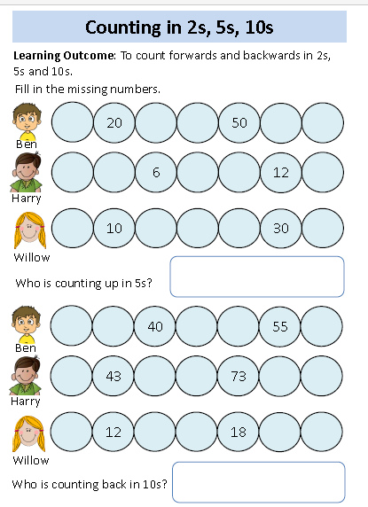
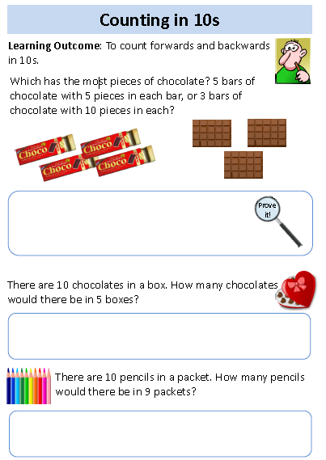

up in 2s?
75
45
In Year 1 we are practising counting in 2s, 5s and 10s. It would be great if you could help them count in 2s, 5s and 10s, starting at 0.

