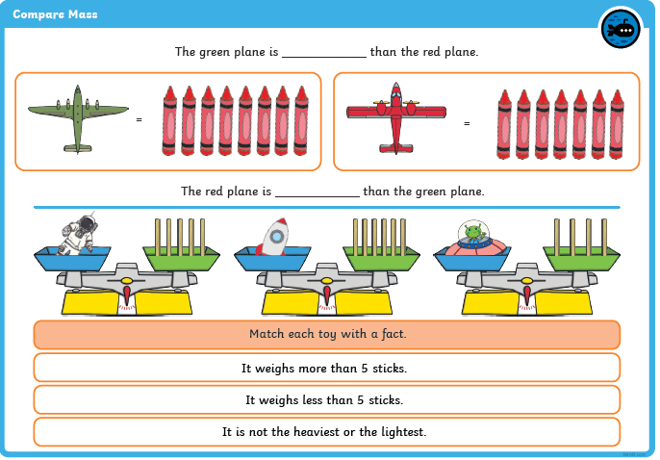
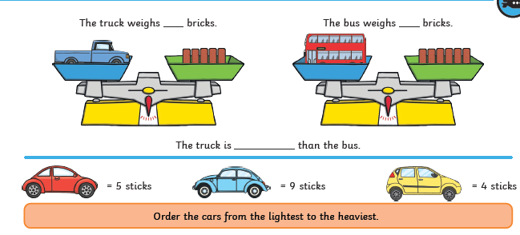
heavier
lighter
Children have been learning about mass. Please complete the worksheet together.

