


The Atkinson Prize Draw History Selfie Competition
February half term 2025
Visit with a grown-up – open Mon to Sat 10am- 4pm
Be a history detective – look very carefully to learn from the exhibitions! Visit the one below in the art gallery which has great paintings of what Southport looked like in the past. Try out the shabti trail.
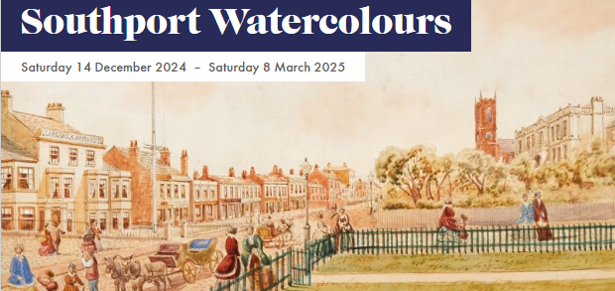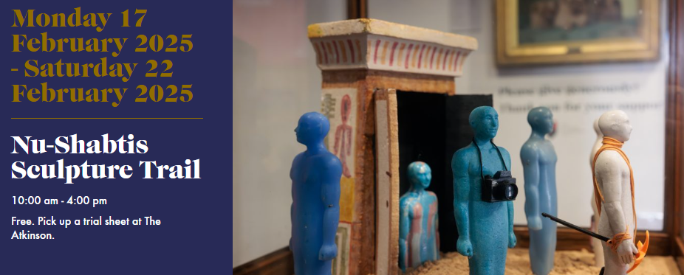
Sending your selfies means you give permission for them to be on display and on our website -Get your grown-up to email photos to me at the email address below

Other selfie opportunities upstairs in the museum -
- Try on the outfits – the glamour of the 1930s or the jobs
- Find the Mekon and take a selfie underneath it
- Pose at the sea bathing frame on your way out
- If the post card computer is working – send one to me using the email below

Please email your selfies or postcards by Friday 28th February 2025 to
competition@sps.sefton.school

Winners will be drawn at random from entries

The Atkinson Prize Draw History Selfie Competition
February half term 2025
Visit with a grown-up – open Mon to Sat 10am- 4pm
Be a history detective – look very carefully to learn from the exhibitions! Visit the one below in the art gallery which has great paintings of what Southport looked like in the past. Try out the shabti trail.
Sending your selfies means you give permission for them to be on display and on our website -Get your grown-up to email photos to me at the email address below

Other selfie opportunities upstairs in the museum -
- Try on the outfits – the glamour of the 1930s or the jobs
- Find the Mekon and take a selfie underneath it
- Pose at the sea bathing frame on your way out
- If the post card computer is working – send one to me using the email below

Please email your selfies or postcards by Friday 28th February 2025 to
competition@sps.sefton.school

Winners will be drawn at random from entries

