Reading comprehension
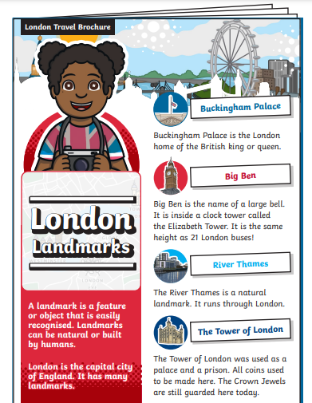
Please share/read the London Travel Brochure. Then the children can answer the questions about what they have read.

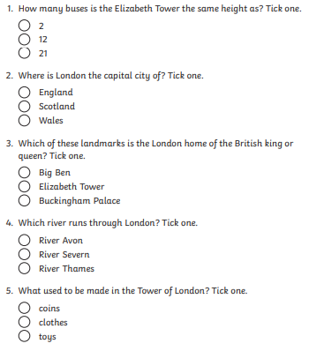

Which landmark would you like to visit and why?
_______________________________________________________________________________________________________________________________________________________________________________________________________________________________________________________________________________________________________

