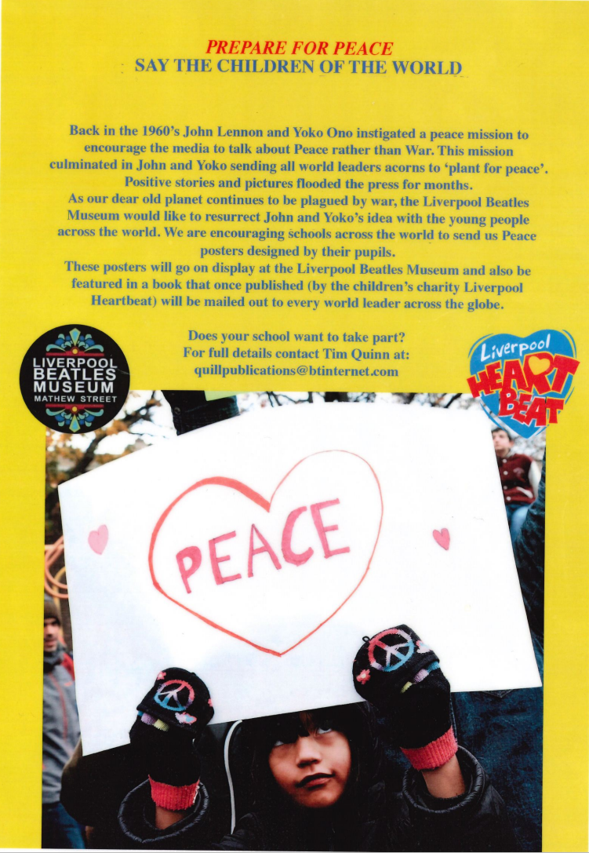
tUR
TPO
With violence and war breaking out across our planet over the last decade, PREPARE FOR PEACE is a campaign created by Liverpool Beatles Museum and the children’s charity Liverpool Heartbeat to give hope to children of the world. We are asking schools and young people from every country across the Earth to create poster promoting peace rather than bloodshed. These posters will be put on exhibition at the Liverpool Beatles Museum before being compiled into book form. Copies of these books will be sent to every world leader during 2025 as ‘the voice of the young people of the world’
Entries should be A4/international paper size with the name, age and school of the artist written on the back.
Deadline: 12 December 2024.
Send all entries to either: quillpublications@btinternet.com
Or: Tim Quinn, 54 Forest Road, Southport PR8 6HZ. UK.
Thank you all and may we PREPARE FOR PEACE!
Tim Quinn Robin Baynes MBE
Liverpool Beatles Museum Liverpool Heartbeat

