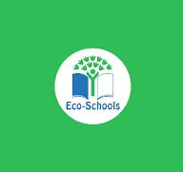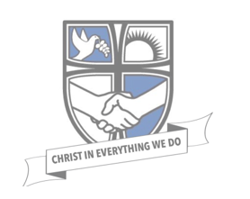

As part of our work on the Eco-flag and sustainability plan, linked to Eco-schools, our Eco Warriors have set a homework competition, that we will judge in school. We have also made a link with our Christian value for this half term, which is creativity.

We have been learning about biodiversity in class and need your help. We would love our playground to have some opportunities for wildlife to visit. Could you design or build/make a bird feeder, bug hotel or a hedgehog friendly environment?
We’d love to see your ideas and our favourites will be kept in school and placed in our outdoor areas to be enjoyed. If you’d rather just bring your design on a piece of paper we’d love those too!
Please bring your creations in by Friday 4th July.


