Week Ending: 15.11.24
Homework due: Wednesday 20th November
Next week…
PE - Tuesday and Thursday
Friday – Southport MP visit

This week…
Year 2 have been very busy going to the Salvation Army for Interfaith Week and going to the cinema for the Into Film Festival! We are also saying a fond farewell to Mr Pigott who is sadly leaving us this week.

Reading:
Please update reading records throughout the week.

Spellings:
In your child’s spelling record book.

Science:
This week in science we have started our new topic of ‘Materials’. We looked at different materials and their properties, thinking about why we use them for different purposes. We found different materials around our classroom.

Your task is to design a ‘Material Muncher Monster’ who wants to eat one type of material, and create a menu for them.
Your monster can be a drawing, or if you have the time you could build it! For example, a metal Material Muncher Monster could be covered in tin foil and have a menu of paper clips, hinges and cars. A paper Material Muncher Monster could be covered in scrap paper and want to eat your exercise books!
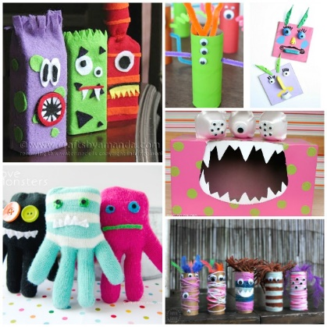
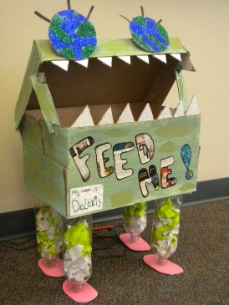
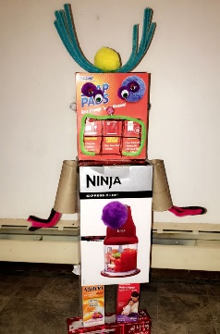
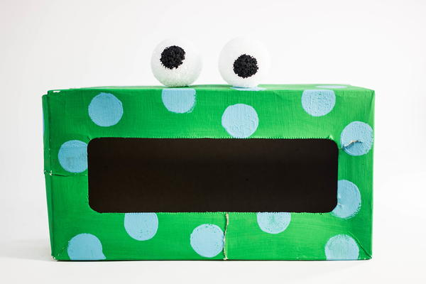

Parent/Carer comments:

