Week Ending: 29.11.24
Homework due: Wednesday 4th December
Next week…
PE - Tuesday and Thursday
Y2 Christmas celebration will be
Thursday 12th December 9-9:30

This week…
We started the poem ‘The Owl and the Pussycat’ in English, and finished off addition and subtraction in Maths. We will keep revisiting this across the year. We also learned about the continents and oceans in Geography and started rehearsing our Christmas performance!

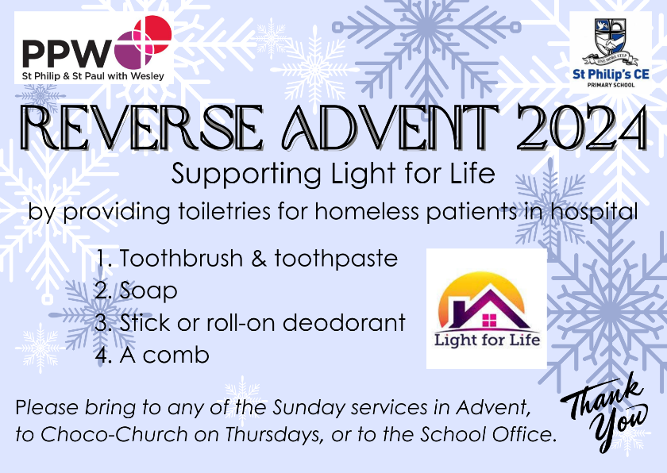

Reading:
Please update reading records throughout the week.

Spellings:
In your child’s spelling record book.

Maths:
You have an arithmetic sheet on addition and subtraction to complete. Make sure you pay attention to the symbol for the question! Links to help can be found on the homework page of the school website.

RE:
Sheet Please see ‘Prepare for Peace’ sheet on next page to design a poster on the theme of peace. Entries should not be stuck into books, and will be handed to Mrs Cooper.

You need your name, age and school written on the back of your piece of paper.

Good luck and have fun!

Parent/Carer comments:

