Week Ending: 6.12.24
Homework due: Wednesday 11th December
This week…
Year 2 have worked very hard on their maths and English assessments – they tried our best and made their teachers proud! they have also been rehearsing for our performance next week. Please practice lines over the weekend!
Next week…
PE - Tuesday and Thursday
Christmas Performance Thursday 9-9:30

Reading:
Please update reading records throughout the week.

Spellings:
In your child’s spelling record book.

Performance:
Please practice your lines! We only have two more rehearsals before the big show!

Design Technology:
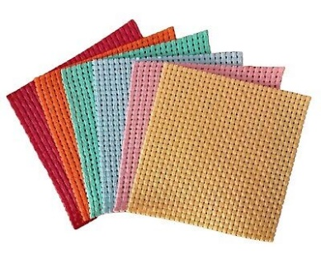
Over the next two weeks, Year 2 will be creating their own Christmas decorations with sewing. Your homework is to research decorations that already exist to give you some ideas for your decoration.

We will be using binca fabric with easy to see holes to help with sewing. (We also have some felt if you can already sew.)

We will be having an afternoon of sewing on Monday 16th December – if there are any grown ups at home, mums, dads, grandparents, who are able to sew and available to help that afternoon please let Mrs Wright know on wrightl@sps.sefton.school . The more helpers the merrier!

We may need helpers on the Wednesday afternoon too, depending on how Monday goes! Thank you for your support!
Parent/Carer comments:

