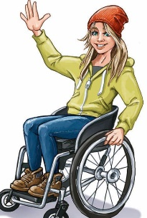
TIME TRAVELLER TASK: The Ancient Egyptians PROJECT
A project is supposed to take several weeks. Stage 1 = research. Stage 2 and 3 write it. Stage 4 the finishing touches like title page, contents and bibliography (list of websites/books used)
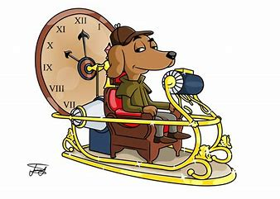
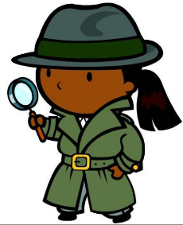
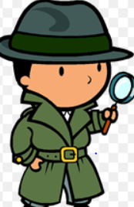
Ask most people about lives in Ancient Egypt and if they know anything, they will say they were very different from us - Horrible Histories calls them Awful Egyptians. Sometimes history gives too much attention to just one side of a story. What is different can seem more interesting and exciting than what is the same about a group of people.
Your task
LO: To write a as a time traveller to the time of the Ancient Egyptians. Your mission is to explore what was similar and different to how we live today. Finish with an answer to the question: Were lives in Ancient Egypt really so different from lives today?
Good = you can list lots of similarities and differences
Very good = you can write in paragraphs to show similarities AND differences
Excellent = AND you can weigh up these similarities and differences to give a convincing answer to the question above.
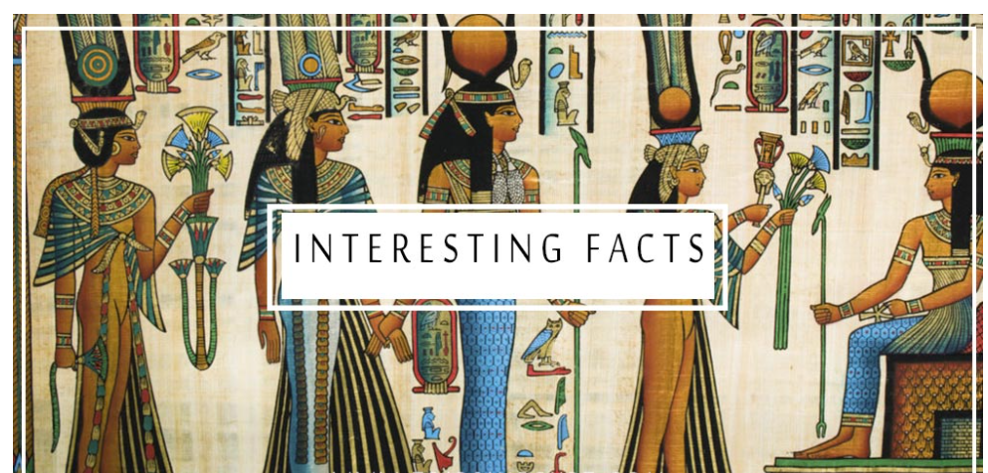
Ancient Egypt began about 5000 years ago – around 3000 BC (Before Christ was born)
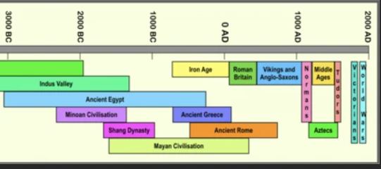
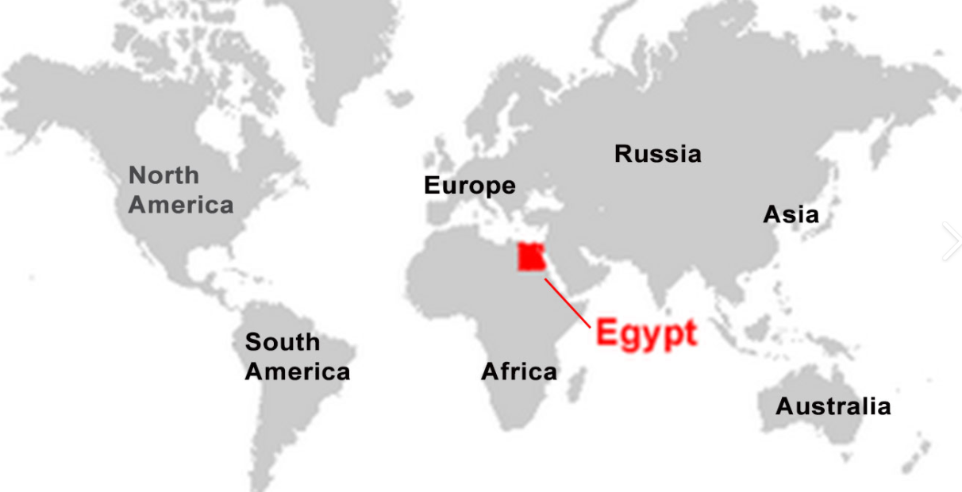
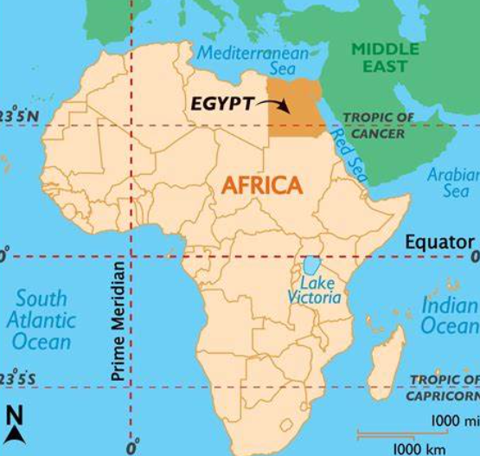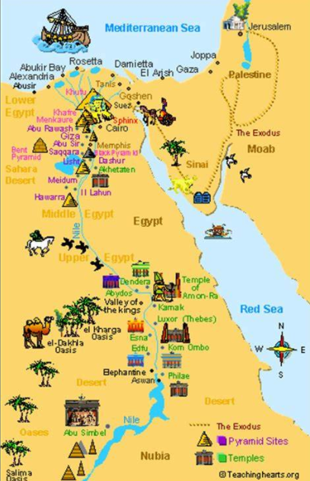

Stage 1….Research stage
Think about what you’d like to know about these people – what questions would you ask? Think about how we live today – Did they live in families? Did they believe in God? Did they have similar homes and buildings? Did they play any games like us?
Use websites like these to find out what lives were like.
An introduction to Ancient Egypt - BBC Bitesize
What was life like for the ancient Egyptians? - BBC Bitesize
What games did the ancient Egyptians play? - BBC Bitesize
What did the ancient Egyptians believe in? - BBC Bitesize
Ancient Egyptian beliefs and the construction of the Pyramids - KS2 History - BBC Bitesize
Building the pyramids (pt 1/5) - KS2 History - BBC Bitesize
Working life in Ancient Egypt - KS2 History - BBC Bitesize
History KS2: Ancient Egypt - Life and Death in the Valley of the Kings - BBC Teach
Now list in tables like this what you think about what you have found out. You can choose your own topics: these are just ideas

Different to us | Neither/not sure/both |  | Similar to us
Homes
Made of mud and straw (adobe)  Sleep on the flat rooves  No inside toilets or showers  No windows  No electric |  |  | Rooms like kitchens for cooking  Living rooms for socialising
Food
Beliefs/religion/afterlife/gods
Games
Jobs/tasks/chores
Women’s lives
Children’s lives

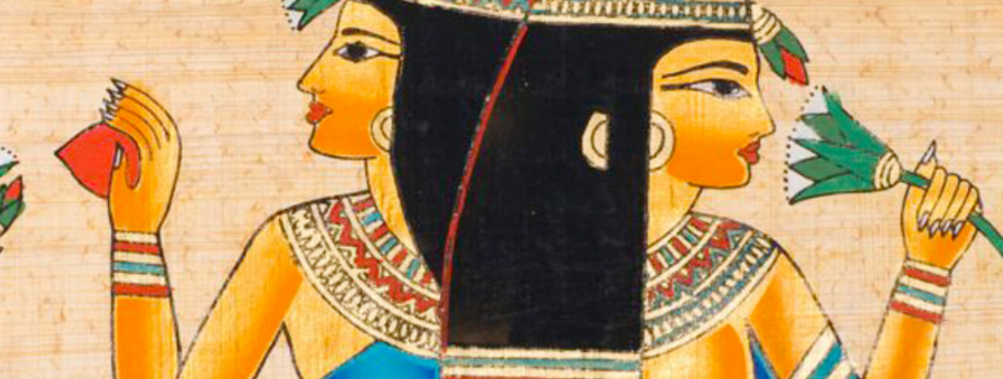

Stages 2 and 3 = Now you can start to write your project. You can hand write or use a computer. There are 3 parts to this.
1 = Write an introduction. Remember you are writing as a time traveller. You need to explain what your task is and set the scene. This should be fun but you need to make this is your best writing so take care with punctuation and spelling. You should be trying to show off correct use of advanced punctuation and more complex sentences such as those starting with fronted adverbials. Here is an example:
Spinning rapidly through time, my challenge in this project is to travel back to investigate the Ancient Egyptians. Wish me luck! Aargh….my time machine gave has given me a headache. I’ve travelled back in time four thousand years. I’ve crash landed in Ancient Egypt on the continent of what we call Africa. I’m going to investigate and find out just what its like to live here. My task is to find as many similarities and differences as I can and then weight them up to answer the question:
Were lives in the Ancient Egypt really so different from lives today?

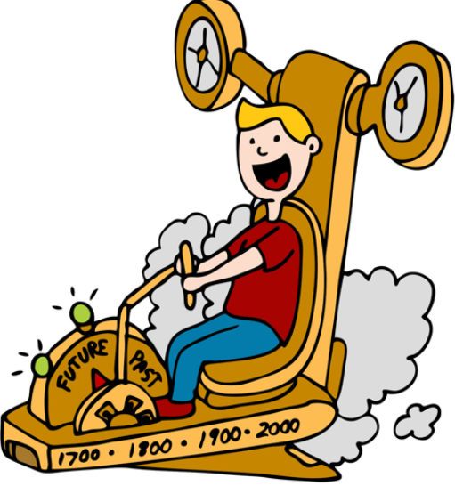

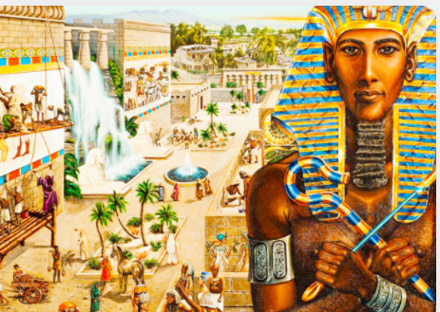
2 = Now write your chapters: give each one a title and write making it really clear what is similar and different
Different | Similar
different  strange  unusual  We don’t do this  I’ve never seen anything like this before | similar  the same  I recognise this  just like we do  familiar
Chapter 1 Homes and towns
Staggering slowly out of my time machine, I find myself next to some Ancient Egyptian homes. I see that some things are similar here. They have walls and windows and doors. I get to see inside, and I can see kitchens, living rooms and bedrooms. In the living room I can hear people talking and laughing together just like we would do. In the kitchen there are the smells of food cooking and I see familiar food like eggs, figs and grapes being prepared. There is no sign of food like tomatoes and potatoes as these had not yet been discovered. As night falls, I notice something strange. People are sleeping on the rooves! Imagine if we did that! I guess they do this because it gets so hot inside. The Egyptians do not have air conditioning and fridges like we do to keep themselves and food cool. I see that they are storing food in the ground to keep it cool. They don’t have gas or electric so nights seem longer without lights and food is cooked in clay ovens not in electric cookers.
I walk further and see more of the town …..
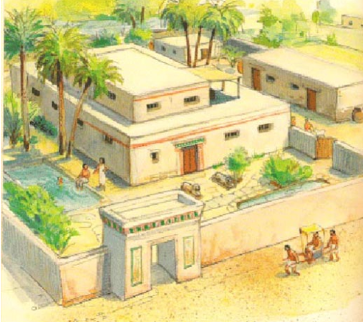
Try to write between 3 and 5 chapters. Make sure you read over your work and neatly correct any mistakes. You can add pictures too. Either draw them yourself or copy from a website.
3. Now it is time to write your conclusion. You have investigated and written about your findings in your chapters. Your conclusion is your summary, where you weigh up the similarities and differences.
Here is an example. Don’t copy it though! You must make sure that you give the answer that fits your investigation. If you have found more differences that is what you must say!
Wow! I loved travelling back in time. It was great to experience the sights and sounds and smells of Ancient Egypt. I found out so much! I thought it would feel vastly different living so long ago but in fact many things were similar to today. They ate many similar foods and lived in homes that had many similarities to ours. They lived in families and had a religion that was important to them. They farmed, spent time socialising and had a range of jobs similar to today. Of course, there were some big differences. Their religious beliefs were very different with many gods rather than just the one. Their pyramids are enormous tombs whereas we have small gravestones. They didn’t have toilets and showers in their homes. With no electricity or cars, they didn’t travel so much or have so many fun things as us. Overall, I think their lives were a mixture of similar and different.
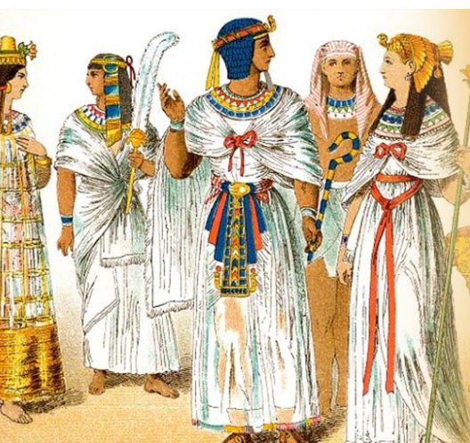
Extra challenge – can you compare with the other projects such as The Shang or The Indus Valley - and say what they have in common – why did they become so successful – are they similar to each other?

Stage 3 = The finishing touches- there are 3 of them
- Create a content page
This says what is on each page e.g.
Contents
Introduction
Chapter 1, 2 ,3 and 4
Conclusion
Bibliography

- Make a list- either under your contents or on a back page- of all the websites and books you have used
Bibliography
What was life like for the ancient Egyptians? - BBC Bitesize
What games did the ancient Egyptians play? - BBC Bitesize
What did the ancient Egyptians believe in? - BBC Bitesize

- Lastly…you have almost finished….enjoy designing a title page. It must include
Your name
A title like My Ancient Egypt Investigation
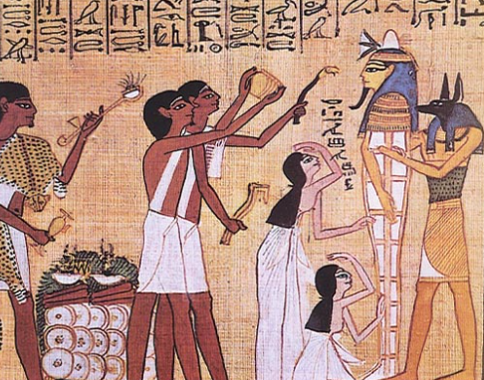

My Ancient Egypt Investigation by Jane Smith

