Half term kindness challenge
Our School Council are running a Kindness Challenge in line with the NSPCC 21st - 24th October.
The 5 kind acts challenge | What have I done? | Tick if complete
Monday
Tuesday
Wednesday
Thursday
Friday
Saturday
Sunday

Choose your own acts of kindness (ideas below) and write them into the table above.
Any homework with 5 kind days and signed by an adult to say they have achieved this, will earn privilege card for extra break/play.
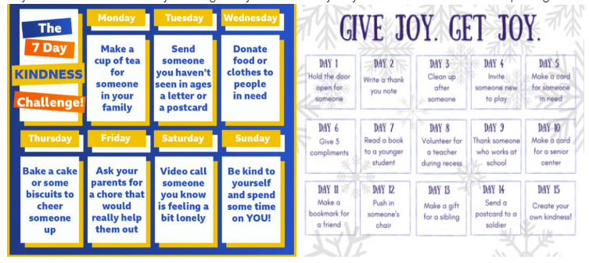
Please take care if making hot drinks or baking – please ask permission from an adult first.

