Week Ending: 6.9.24
Homework due: Monday 9th September
Next week…
- PE – Monday and Friday.
- Pupil visit from Birkdale and Greenbank High School – Tuesday 2:30pm.
- In maths we are recapping and developing place value knowledge
- In English we are going to continue to read ‘Cosmic’
- Our value is Agents of change. Please bring things in to show this value to bring our worship table alive! This could be artwork, news articles, stories etc

This week…Welcome back to school and welcome to Year 5! We have settled into our new classroom and are getting used to the changes in UKS2. We have so much exciting learning ahead this year! PE will be on Friday.

At Home…
Reading:
It is so important that your child reads frequently throughout the week. At least 3 reading entries should be completed across the week, recording the book title and the pages read in the reading record book.

Spellings:
Please refer to the half termly overview for weekly spelling lists. This can also be found on the Year 5 class page on the school website.
You can also find a copy of Year 5 Spelling Passport words in this homework book, along with a ‘spelling menu’ of ideas on how to learn spellings at home.

Maths:
Please have a go at one (or both) of these place value games below to get ready for our maths lessons next week. These games can be found via this link: www.topmarks.co.uk/maths-games/7-11-years/place-value
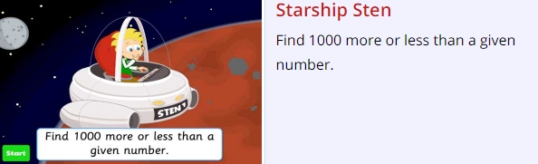
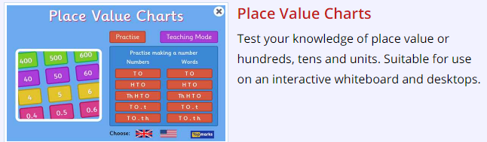

Please continue to practise multiplication tables at home.
Please note that late or missing homework will be completed during Thursday lunchtime.

Parent/Carer comments:

