Week Ending: 27.1.23 Homework due: Tuesday 31st January 2023

Next week…
- Monday – MUSIC MONDAYS – please bring your instruments into school + Homework ASC + Sweaty Church ASC
- Tuesday – PE Day + Choir ASC
- Wednesday – PE Day + CLASS WORSHIP – for the adults of the 6 pupils invited – 3:00 at the office + Multi-Sports ASC
- Thursday – Tag rugby ASC

This week…
From being advert directors to dividing like mathematicians, this week has been fantastic. We had a visit from our history ambassadors and have got to grips with effective searching on an internet search engine
Many thanks,
Mr Vernon

At Home… Reading:
My Weekend entry for my school book or my own choice of reading book

The book I read: _______________________________
Pages read: _____________________

Adult’s score
Rate your reading
Tick if complete
Spellings:
Please practice WEEK 5 for words with a short ‘i’ sound spelt with a ‘y’.
Maths:
- Zulus, Yankees and Victors complete page 26 on multiplication and division solving problems.
- Limas and Echos complete page 27 on multiplication and division word problems.
RE:
- Mrs Cooper has invited children to complete a ‘love’ homework task also stuck in books. Be creative!
Bonus:
- Write an advert for sunshine soap using persuasvie language!
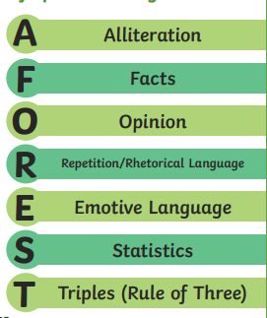
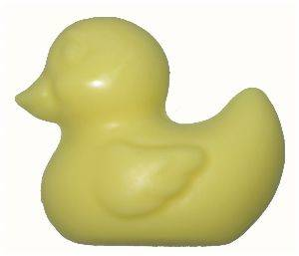

Missing homework will be completed in Wednesday/Thursday lunchtimes.
Parent/Carer comments:

Adult Signature: ……………………………………

