Homework set 16th of December 2022
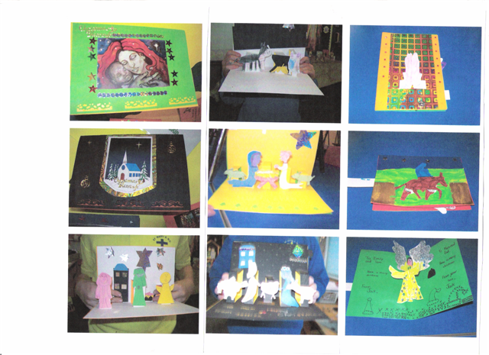
In preparation for our Christmas Card making next week we would like all children to create a design that they can make in school. In year 3 we are looking at pop up cards, therefore children will need to design a card that has both something that will pop open inside the card when it is opened but also something that can be moved in the background by pulling a lever. Below are some examples you may wish to use for inspiration. We are making the cards on Tuesday the 20th so designs must be completed before then. The children can draw them on the next page! Have fun! – Mr Vernon and Miss Chambers

