Set: Friday 24th Feb Homework due in by: Weds 1st March
This week…We have started our non-chronological reports for RE about Communion.
- We have written newspaper reports about volcanoes

Next week: WORLD BOOK DAY- Thurs 2nd March- Poetry fest!
This will be a fun-filled day – come dressed in your festival outfit- wellies, hats, sunglasses, jazzy clothes!
Swimming on Thurs 2nd March for those who took permission letters for the gala. This group of children will be late returning to school- back approx. 3.30 pm.
PE next week is Tues and Weds- please come in your school uniform on Monday.

Reading: It is important that you read frequently throughout the week- at least three times. Please record in your reading record.
Spellings:

At least half a page in your homework books please! Week 2- Word families
*IDL children- please do at least 15 minutes of IDL practise – English and Maths!
Christian Value for Spring 2- Forgiveness
Please bring something in from home to link to new value- to be shared in class worship next week. This could be an object, newspaper report, quote, story book, photo, picture.

Maths- complete page 29 Percentages
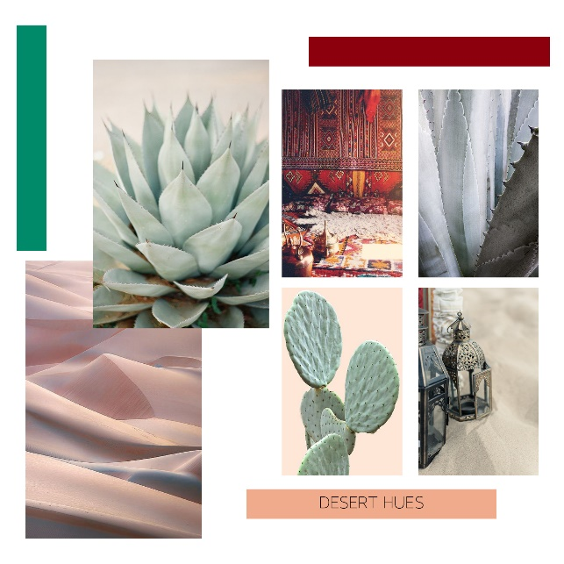
Art : Find out about desert animals and flowers – create a ‘mood’ board of the colours you might find in the desert and collage any pictures you print off…for example…. Use a page of your homework book for this- or you can create it on the computer and print off. Add words to describe…

