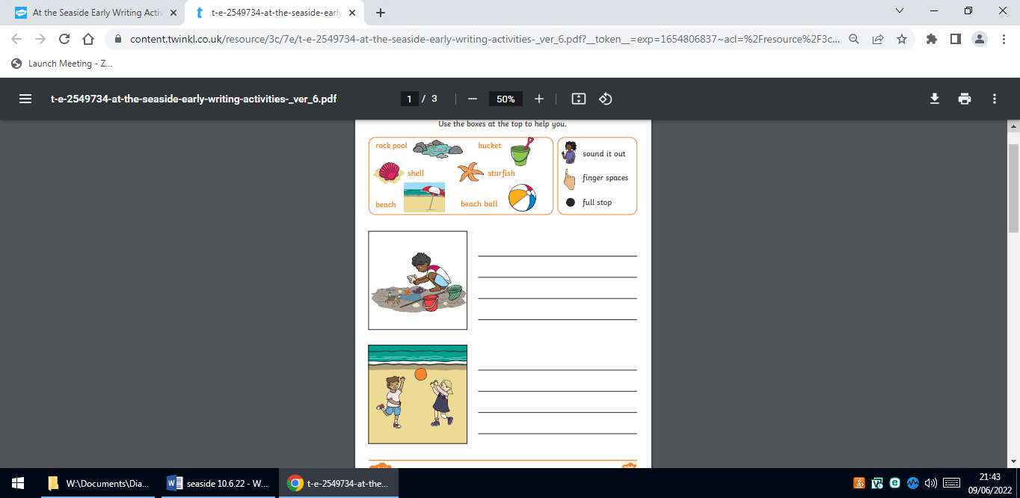
Homework 9.6 23
Our new topic is The Seaside. Please write a sentence about each picture?

