Homework 9.6.23
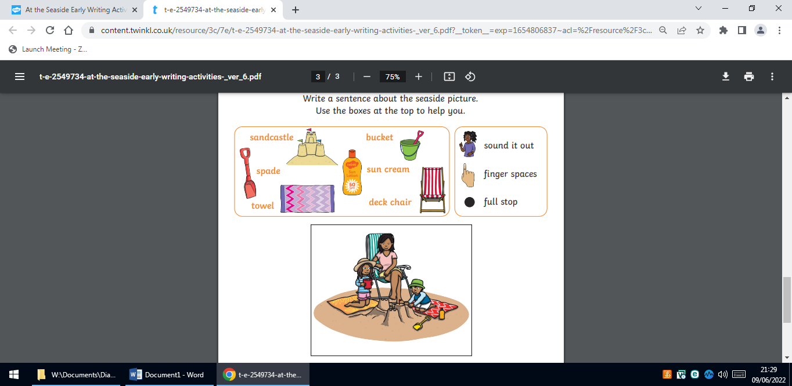
Our new topic is The Seaside. Please write a paragraph about what is happening in the picture?

Homework 9.6.23
Our new topic is The Seaside. Please write a paragraph about what is happening in the picture?

