Year 1 News Your children are working well and really enjoying learning about London. They are full of enthusiasm to learn about all the landmarks.
Please remember to book your place for parent’s evening on line. 27.1.23

We are going to be making some 3D models of London landmarks in Design and Technology. For homework this week can you help your children to think about which landmark they would like to make a model of and complete the design sheet.
They will be using mostly junk materials to make their models. Please can you collect the boxes etc that they will need and send them into school in a named carrier bag.
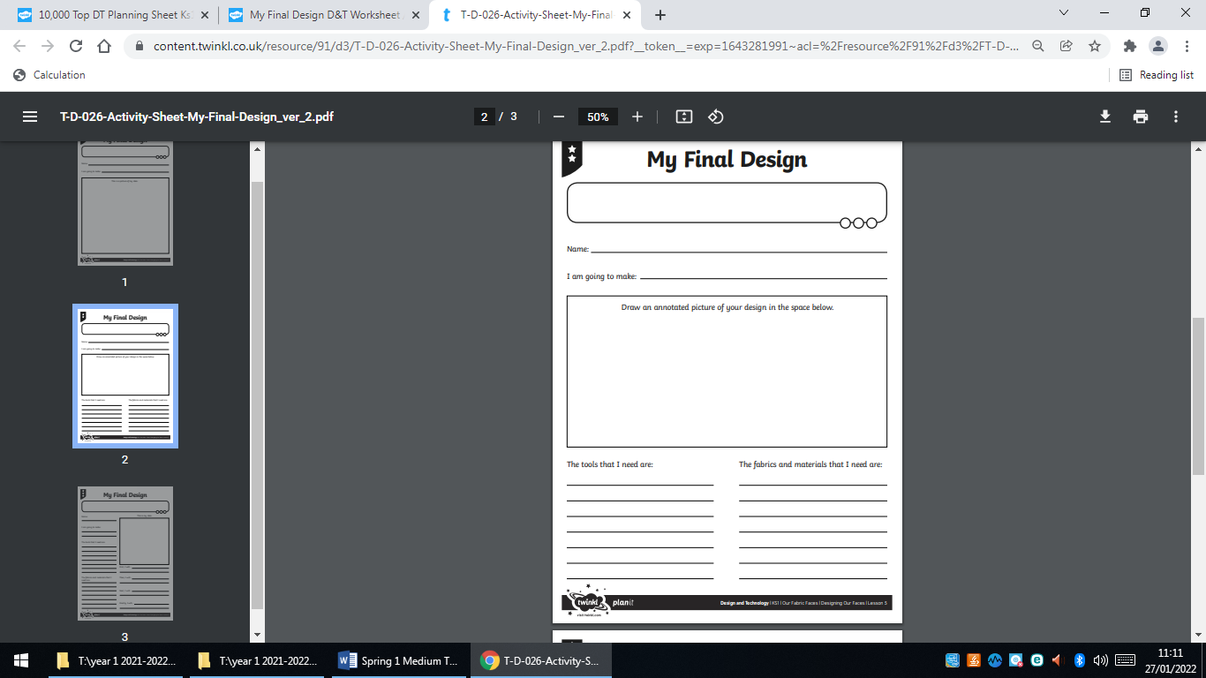
We have paint, paper, glue, scissors, Sellotape etc. so there is no need to bring these in.
Please make sure the children label their picture with what they are going to use for each section e.g. If they are making Big Ben, they may use a Jaffa cake box to make the tower.

