3.2.23 Year 1 News Next week is going to be a busy week. We are going to be making our London landmark models; testing materials to find the best material to make an umbrella for Paddington; learning about internet safety; taking part in an afternoon of mindfulness activities and enjoying the valentine disco. Please make sure your child has planned their model and brought any boxes they need into school. Thank you

Reading comprehension
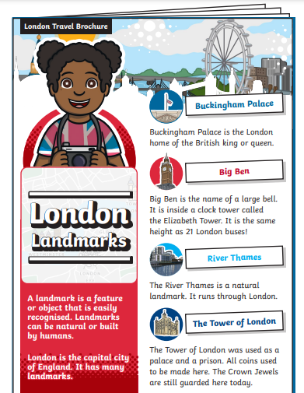
Please listen to your child read the London Travel Brochure. Then the children can answer the questions about what they have read.

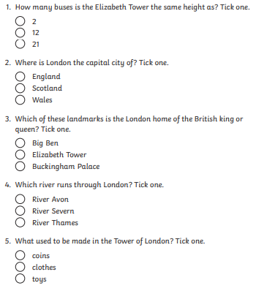

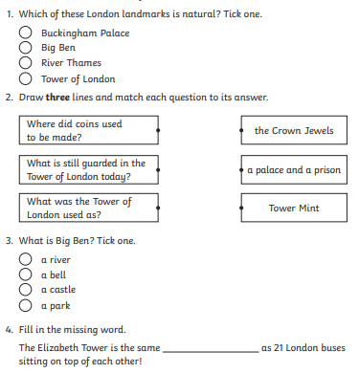

Which landmark would you like to visit and why?
_______________________________________________________________________________________________________________________________________________________________________________________________________________________________________________________________________________________________________

