20.1.23 Homework
Our topic this half term is London.
For homework this week, please can you help your children to find some facts about any of the London landmarks below.
Buckingham Palace The London Eye Tower Bridge
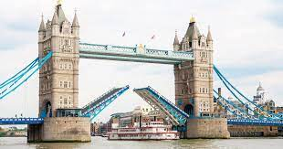
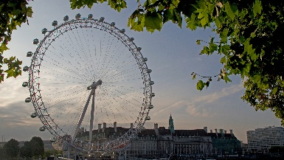
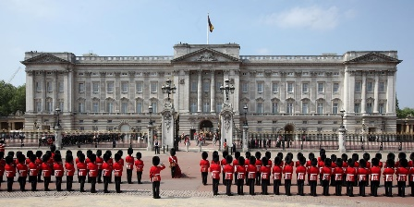

The children will be using some of the facts in their writing next week.
If your child is struggling to write themselves please write for them. Thank you.

To help children develop their fluency in maths we would like them to learn key instant recall facts.
Each week we will learn a new family of number bonds and they will be tested on a Friday after spellings. They will need to be able to write the whole calculations.

This week please learn the facts below.
Number bonds to 1

1 + 0 = 1
0 + 1 = 1

1 – 0 = 1
1 – 1 = 0

