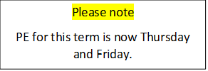
Homework 6.1.23
This week we have been adding ‘s’ to make singular nouns into plurals. Can you fill in the gaps?
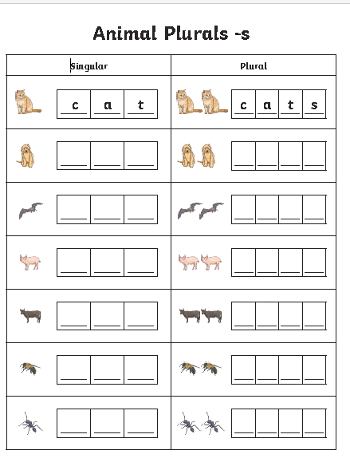
o
e
e
b
w
c

