Homework 6.1.23
Please note
PE for this term is now Thursday and Friday.

This week we have been adding ‘s’ and ‘es’ to make singular nouns into plurals. Can you fill in the gaps and use one of the plural words in a sentence?
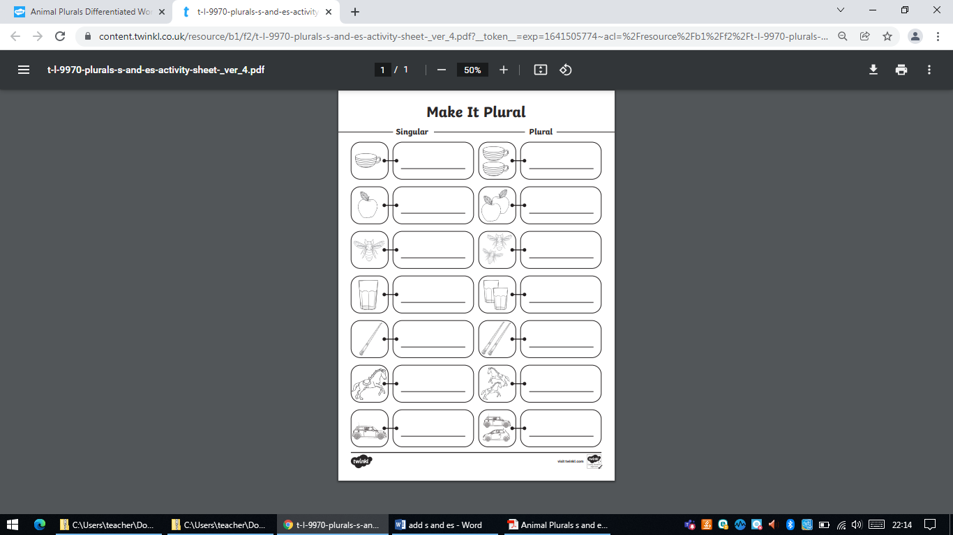
horse
apple
____________________________________________________________________________________________________________________________________________________________________________________________________________

