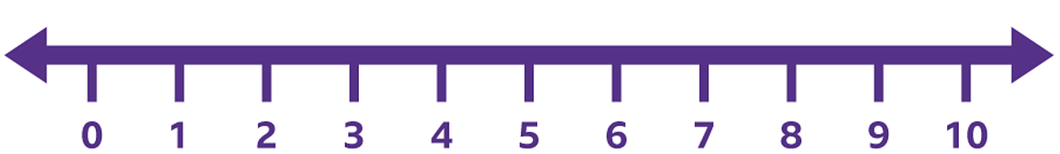
9.12.22 In school we have been using a number line to subtract. Look carefully at the symbols, some are addition and some subtraction


