11.11.22
We are trying hard to learn our number bonds to 10. If you have a spare few minutes please play games with your children to help them remember which two numbers make 10 eg 8 + 2, 6 + 4 etc If you have a computer or tablet, you could play ‘Hit the button’ which is a fun way to practise number bonds to 10. https://www.topmarks.co.uk/maths-games/hit-the-button. Thank you so much.
Please read every night – just a few pages every night makes all the difference. Please remember to write in the children’s reading record book. Thank you to everyone who is reading regularly at home – your children are benefitting hugely from your support.
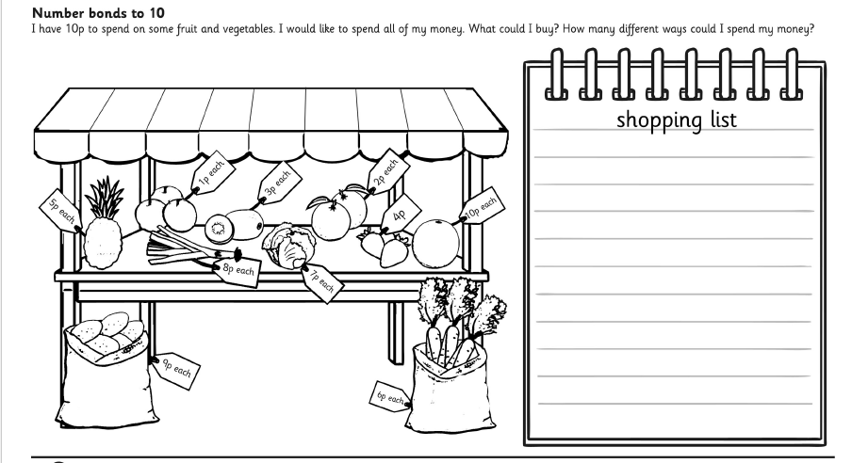
Eg I carrot add 1 strawberry 6p + 4p = 10p

