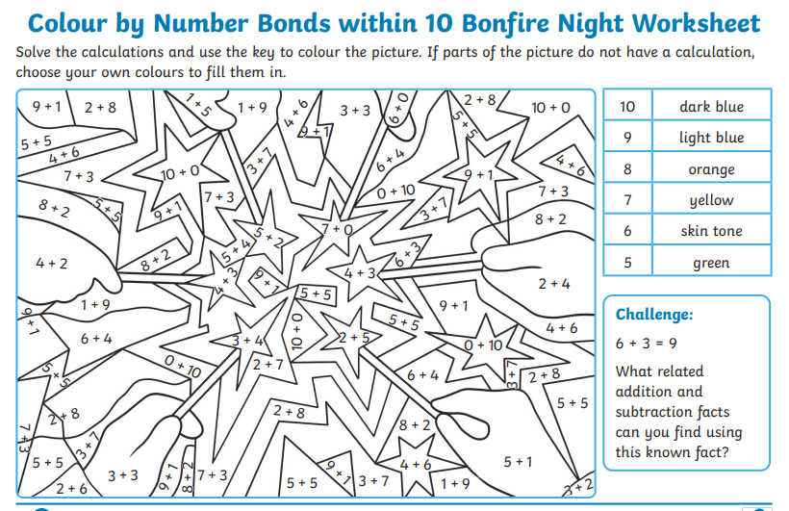
5.11.21
Year 1 News
Hope everyone had a lovely half term.
In school we have counters to help the children when adding two numbers. At home, you could use buttons or dried pasta or Lego blocks.
Have fun.
Please remember to read every night and jot down the pages you have read in the reading record books.
Thank you so much.

