In English this week we have been writing a fact file about a triceratops. We are so proud of how your children are working hard to become independent writers.
In maths we have learnt about the greater than and less than symbols and have been ordering numbers.

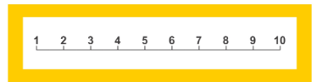
7.10.22

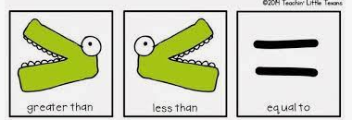
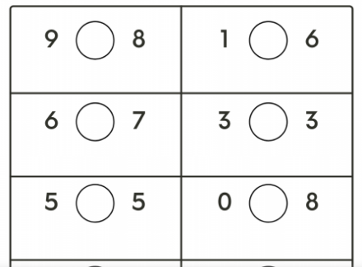
Order these numbers starting with the greatest.
5 1 9

7 1 6
8 1 0 3

Order these numbers starting with the smallest.
2 8 10
4 3 2
4 8 10 2

Can you choose the correct symbol?
< = >

