Year 1 News 23.9.22 This week we read the book Harry and the bucketful of dinosaurs. Harry enjoys taking his dinosaurs on adventures and we wrote our own story about our baby dinosaur’s day out. In maths we have been finding one more than different numbers.
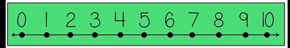
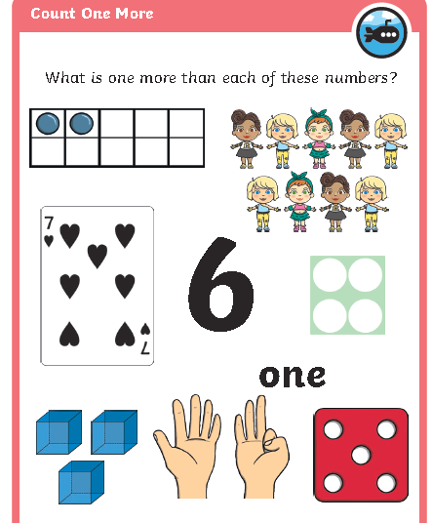

7 is 1 more than ----------- 10 is 1 more than ------------
3 is 1 more than ----------- 6 is 1 more than ------------
1 more than -------- is 4 1 more than -------- is 7

