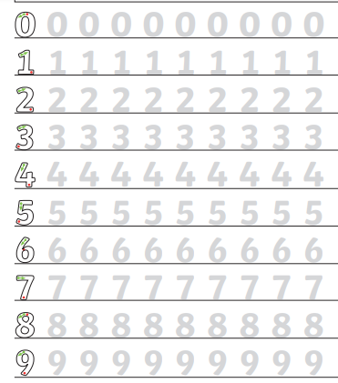
Year 1 homework This week in maths we have been doing lots of counting. Please practise writing numbers correctly – starting at the green arrow. Then fill in the empty boxes – either count the objects or draw the correct number of objects. I have done the first one for you.

Number of objects | group of objects
4 | 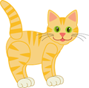  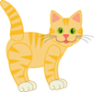
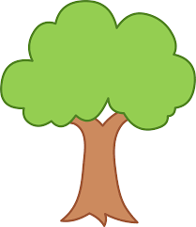

3
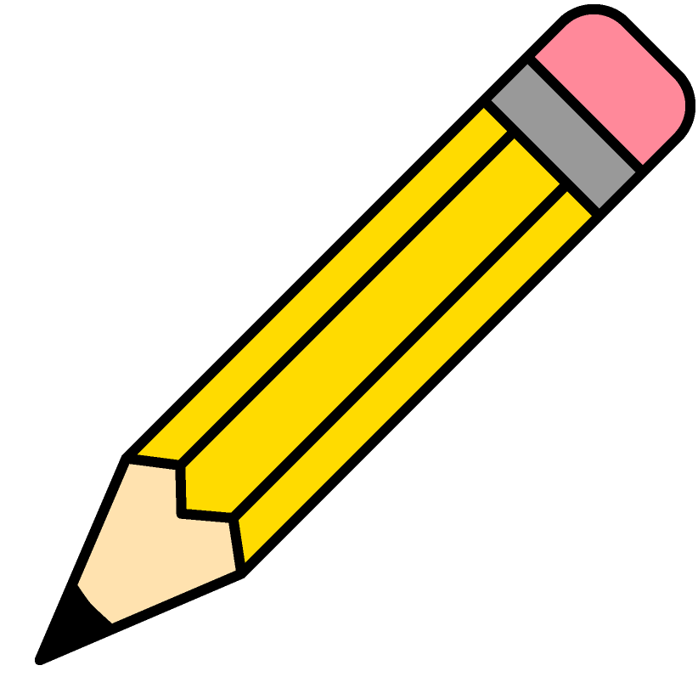


7

