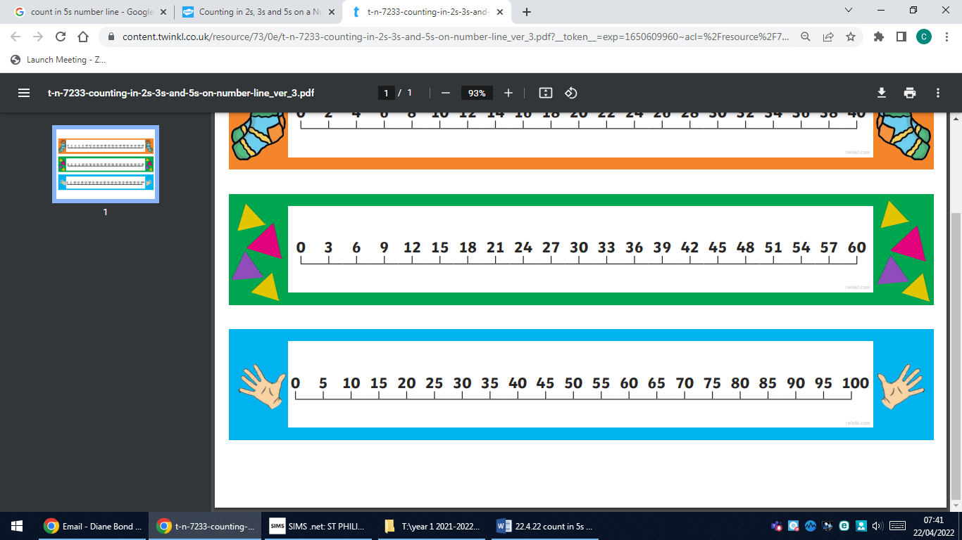
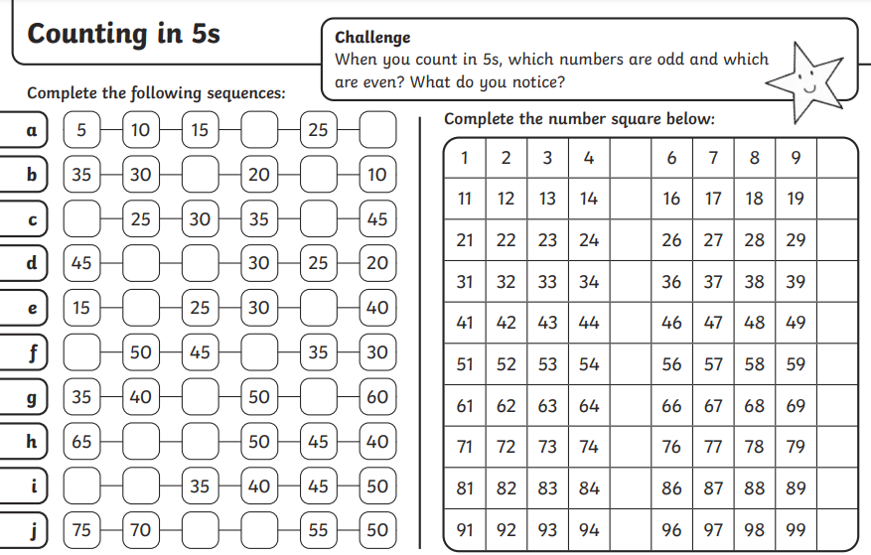
19.5.23 In Year 1 we are continuing to keep practising counting in 2s, 5s and 10s. The children are doing really well when we all count together but sometimes get a little unstuck when counting on their own. It would be great if you could help them count in 2s, 5s and 10s, starting at 0.

