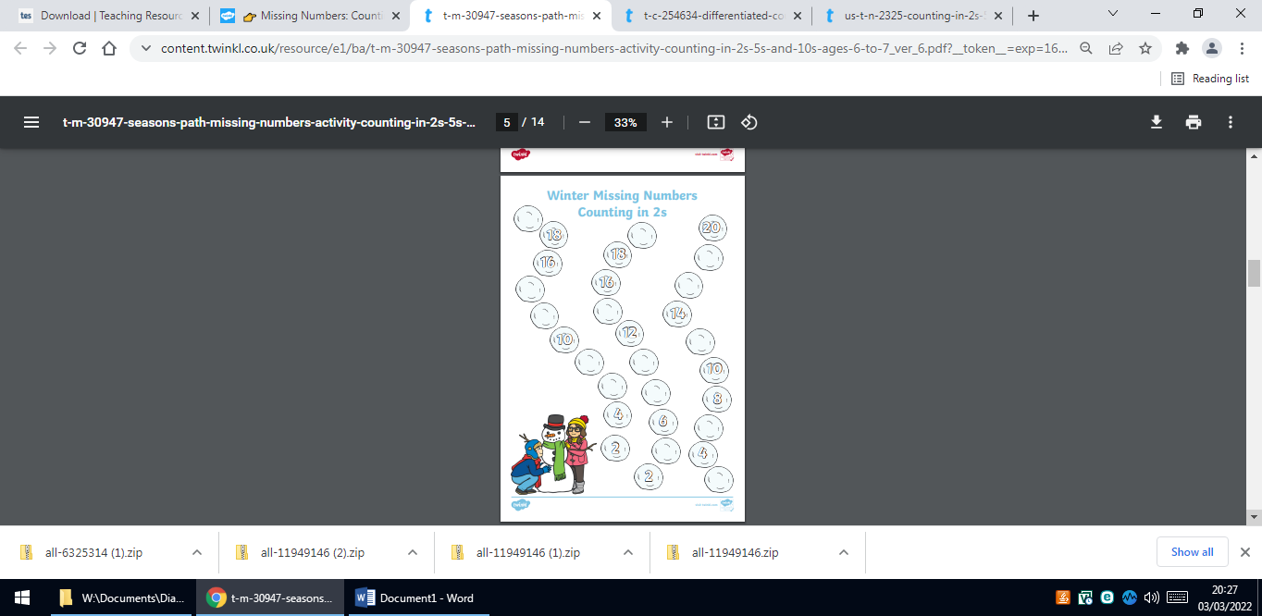
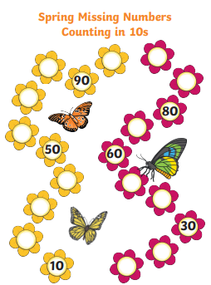
5.5.23 Year 1 News Thanks everyone for dressing in red, white and blue; Friday will be a special day , celebrating the coronation. This week in maths we have been counting in 2s, 5s and 10s. Please keep practising at home.

