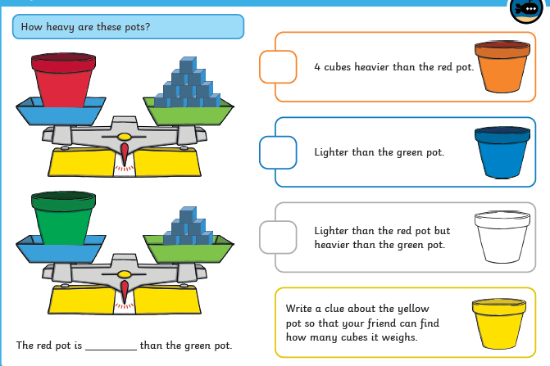
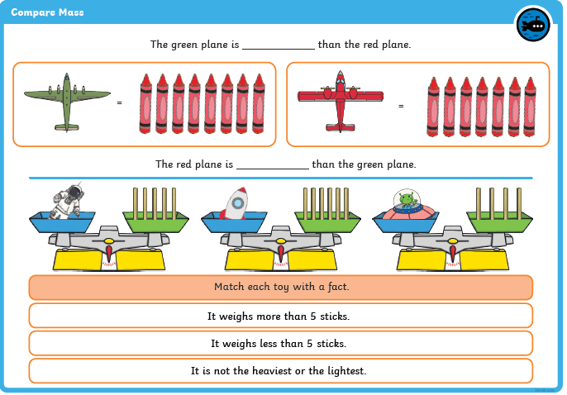
heavier
lighter
Homework 21.4.23 This week we have been continuing our work on measures and have been learning about mass.

