Week Ending: 28.11.25 Homework due: Wednesday 3rd December 2025

Next week… NFER assessment week – We will be completing standardised tests to measure our progress so far.
- Monday – Sweaty Church + Homework ASC PE Day
- Wednesday- Film night- please pay on line to book a place
- Thursday – PE Day (Swimming)
- Friday – Christmas jumper day with uniform-raffle contributions ( Year 4 Smellies)

This week…
This week we have continued practising multiplication and division facts, started looking at non-chronological reports and continued our history work on The Romans. Christmas is fast approaching… please learn lines.
The multiplication check powerpoint I shared in the parents session is on the class webpage under ‘Curriculum.’
Thank you!

.At Home… Reading:
Adult’s score
3 entries in your reading record to claim your dojo!

Spellings
No spellings this week as we will be having our spellings assessed with NFER tests.

Maths:
Complete the multiplication wheels!
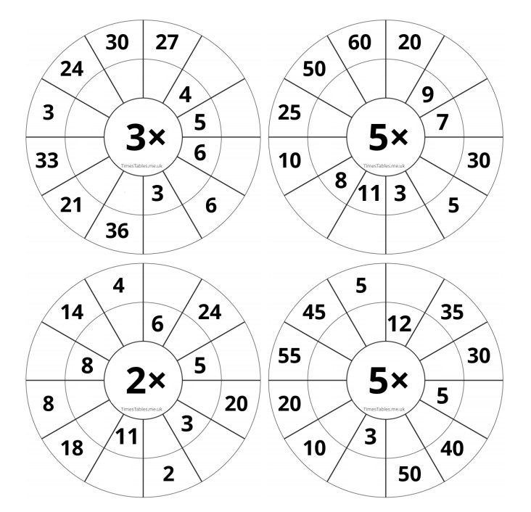

Christmas costumes- please start looking for bits to help with costumes-please do not buy anything! If you need help please ask as we do have some in school.

Shepherds- tea towel, tie, plain dressing gown, dark trousers and PE t-shirt , cuddly sheep toy
Angels- sparkly/white/ silver/ gold top or dress, plain leggings or tights, tinsel for headdress ( we have wings we can supply)
Mary- tea towel, tie, plain dress, plain skirt/ plain top,
Joseph- tea towel, tie , plain dressing gown, dark trousers and PE t-shirt
Innkeeper- tea towel, tie, plain dressing gown, dark trousers and PE t-shirt
Kings- dark trousers and PE t-shirt (we have headdresses we can supply)
Narrators- Christmas jumpers, plain leggings/trousers
Camels- brown/grey top and dark trousers (we can make a headdress of some sort!)
Donkey- grey top and dark trousers (we can make a headdress of some sort!)
Parent/Carer comments:

Adult Signature: ………………………………

