Week Ending: 23.1.26 Homework due: Wednesday 28th January 2026

This week…
We finished our ‘Stories from other cultures’ unit. Geography was a chance to reflect on seasonal food and in RE we wrote diaries from the disciple’s point of view about the Transfiguration of Jesus!

Next week…
- Monday – Sweaty church + Homework ASC (invite only) PE day
- Tuesday –
- Wednesday – PE day
- Thursday –
- Friday –

.
At Home… Reading:
Adult’s score
3 entries in your reading record to claim your dojo!

Spellings
Please refer to the back of your homework books for spelling lists for Friday’s test. Use the table below to practice.
List 3
Copy the word | Cover and spell | Copy again | Cover and test yourself
subheading
subway
supervise
superstar
superpower
superhuman

Maths:
Please complete page 24 on Written Multiplication.

English- SPAG.com test – Direct speech – test C

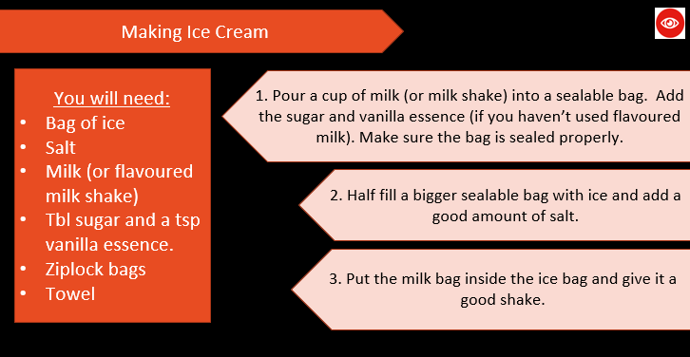
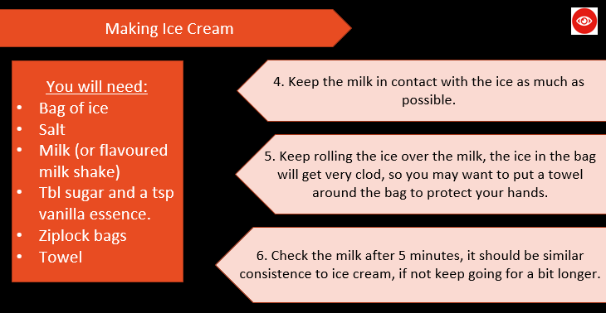
Science- Making icecream! Optional task! We have been learning about changing state in Science- watch the You tube clip and follow the steps to make your own icecream. Think about what materials have changed state. Take a photo and either email it into Mrs Cooper or print off and bring in to show the class! https://www.youtube.com/watch?v=luCFF3qGWvQ

Parent/Carer comments:

Adult Signature: ………………………………

