Week Ending: 28.2.25 Homework due: Wednesday 5th March 2025

Next week…
- Monday – Sweaty church + Homework ASC (invite only) PE day
Atkinson library visit- please ensure you have clicked permission online.
- Tuesday –
- Wednesday – PE day
- Thursday – World book day- choose your clothes!

This week…
Welcome back! We have started a new topic in Maths -fractions- and have enjoyed beginning our new class novel, How to train your dragon! A curriculum newsletter has been emailed – it is also on the class webpage. Please do look at this for more information about what we will be learning this half term.

.
At Home… Reading:
Adult’s score
3 entries in your reading record to claim your dojo!

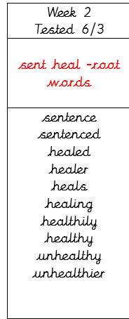
Spellings. We will be focusing on different spelling patterns each week during ELS spelling sessions (Essential Letters and Sounds) as a follow-on scheme to the phonics the children covered in Key Stage 1. A half term overview has been sent home this week and is on the website. Using the grids as a reminder-please practice your spellings on the sheets. You must join up!
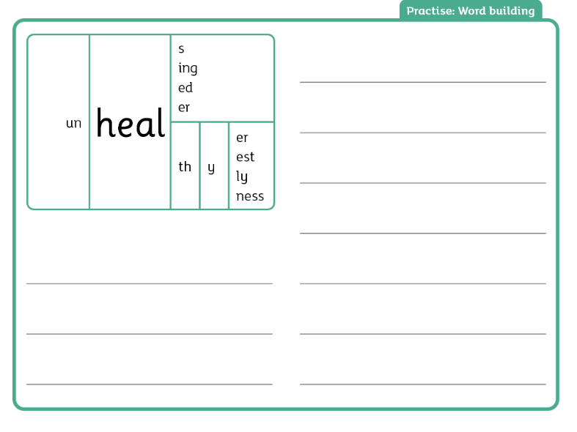

Maths: Revision- subtraction- complete page 15

SPaG:
https://www.youtube.com/watch?v=DR9FGjcG2TMz
Please complete Apostrophes revision.
https://www.bbc.co.uk/bitesize/articles/zdsthbk

Parent/Carer comments:

Adult Signature: ………………………………



