Week Ending: 6/3/26 Homework due: Wednesday 11th March 2026

This week…
We have made practise models of our DT chairs! We enjoyed a lovely visit to the Atkinson library (photos on the class web page) and picked some books to read together in class.
World book day was great fun!

Next week…
- Monday – Sweaty church + Homework ASC (invite only) PE day
- Tuesday –
- Wednesday – PE day
- Thursday –

Eco centre trip- Tuesday 17th March- please ensure you have clicked permission on line.

.
At Home… Reading:
Adult’s score
3 entries in your reading record to claim your dojo!

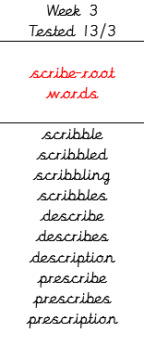
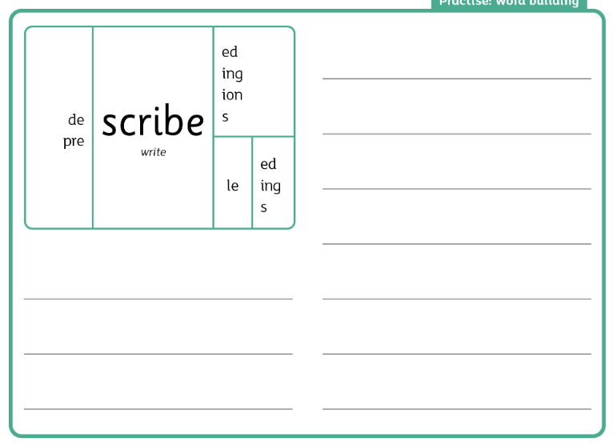
Spellings. We will be focusing on different spelling patterns each week during ELS spelling sessions (Essential Letters and Sounds) as a follow-on scheme to the phonics the children covered in Key Stage 1. A half term overview has been sent home and is on the website. Using the grids as a reminder-please practice your spellings on the sheets. You must join up!

Maths: Time tables practice- please do two rounds of TTRS and complete the revision sheet.

RE: Please bring in anything that links to our Chirstian Value for this half term- Perseverance. Please complete the speech bubble to explain your item- remember your name!
https://www.youtube.com/watch?v=DR9FGjcG2TMz

Parent/Carer comments:

Adult Signature: ………………………………



