Week Ending:17/4/26 Homework due: Wednesday 22nd April

Next week…
Monday – PE day
Sweaty church + Homework ASC (invite only)
Thursday- PE day

This week…Welcome back! We hope you had a lovely Easter break.
This week we have started our new English unit- fantasy stories- looking at the book ‘The lion, the witch and the wardrobe’. In Science we started our new topic – Electricity.
A new half term overview has been emailed out and is also available on our class webpage.

.
At Home… Reading:
Adult’s score
3 entries in your reading record to claim your dojo!

Spellings
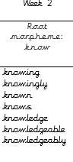
We will be focusing on different spelling patterns each week during ELS spelling sessions (Essential Letters and Sounds) as a follow-on scheme to the phonics the children covered in Key Stage 1. A half term overview has been sent home and is on the website. Using the grids as a reminder-please practice your spellings on the sheets. You must join up
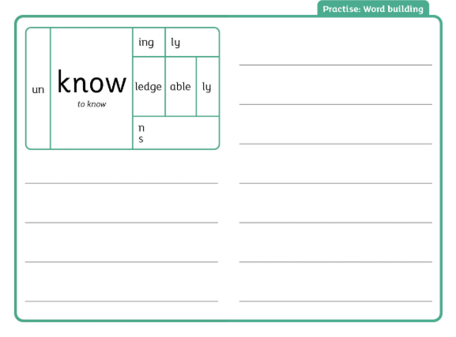

Maths: Shape revision- page 44 Maths book.

Use https://www.bbc.co.uk/bitesize/topics/zvmxsbk to help revise.

SPaG: Pronouns revision – Past and present= Purple Mash To do
https://www.youtube.com/watch?v=DR9FGjcG2TMz

https://www.bbc.co.uk/bitesize/articles/z37xrwx to help revise.
https://www.bbc.co.uk/bitesize/articles/zdbdcmn

Adult Signature: ………………………………

Week Ending:17/4/26 Homework due: Wednesday 22nd April

Next week…
Monday – PE day
Sweaty church + Homework ASC (invite only)
Thursday- PE day

This week…Welcome back! We hope you had a lovely Easter break.
This week we have started our new English unit- fantasy stories- looking at the book ‘The lion, the witch and the wardrobe’. In Science we started our new topic – Electricity.
A new half term overview has been emailed out and is also available on our class webpage.

.
At Home… Reading:
Adult’s score
3 entries in your reading record to claim your dojo!

Spellings
We will be focusing on different spelling patterns each week during ELS spelling sessions (Essential Letters and Sounds) as a follow-on scheme to the phonics the children covered in Key Stage 1. A half term overview has been sent home and is on the website. Using the grids as a reminder-please practice your spellings on the sheets. You must join up
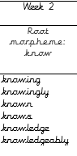

Maths: Shape revision- page 44 Maths book.

Use https://www.bbc.co.uk/bitesize/topics/zvmxsbk to help revise.

SPaG: Pronouns revision – Past and present= Purple Mash To do
https://www.youtube.com/watch?v=DR9FGjcG2TMz

https://www.bbc.co.uk/bitesize/articles/z37xrwx to help revise.
https://www.bbc.co.uk/bitesize/articles/zdbdcmn

Adult Signature: ………………………………

Week Ending:17/4/26 Homework due: Wednesday 22nd April

Next week…
Monday – PE day
Sweaty church + Homework ASC (invite only)
Thursday- PE day

This week…Welcome back! We hope you had a lovely Easter break.
This week we have started our new English unit- fantasy stories- looking at the book ‘The lion, the witch and the wardrobe’. In Science we started our new topic – Electricity.
A new half term overview has been emailed out and is also available on our class webpage.

.
At Home… Reading:
Adult’s score
3 entries in your reading record to claim your dojo!

Spellings
See separate sheet to practise more

Write-in cursive!
door
floor
poor
because
find
kind

Maths: Shape revision- page 44 Maths book.

Use https://www.bbc.co.uk/bitesize/topics/zvmxsbk to help revise.

SPaG: Pronouns revision – Past and present= Purple Mash To do
https://www.youtube.com/watch?v=DR9FGjcG2TMz

https://www.bbc.co.uk/bitesize/articles/z37xrwx to help revise.
https://www.bbc.co.uk/bitesize/articles/zdbdcmn

Adult Signature: ………………………………

Rainbow Writing 🌈
Write each word again using different colours (or underline in different colours if no pens).
door
floor
poor
because
find
kind

3. Fill in the Missing Letters
d__ r
fl r
p r
bec __se
f__nd
k__nd

4. Choose the Correct Spelling
- dor / door
- florr / floor
- pore / poor
- becos / because
- fynd / find
- cind / kind

Write-in cursive!
knowing
knowingly
known
knows
knowledge
knowledgeably



