Week Ending:24/4/26 Homework due: Wednesday 29th April

Next week…
Monday – PE day
Sweaty church + Homework ASC (invite only)
Thursday- PE day

This week…
We have continued our Fantasy story English unit by practising writing setting and fantasy character descriptions. In Maths we have started a new topic- Decimals.

At Home… Reading:
Adult’s score
3 entries in your reading record to claim your dojo!

Spellings
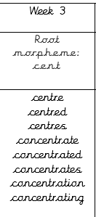
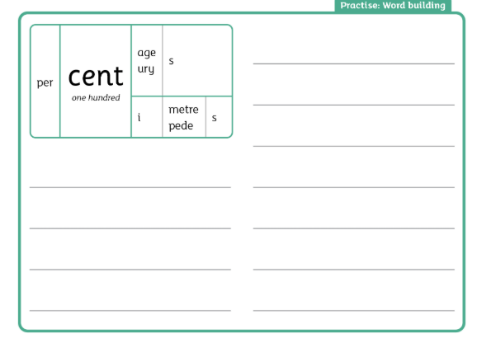
We will be focusing on different spelling patterns each week during ELS spelling sessions (Essential Letters and Sounds) as a follow-on scheme to the phonics the children covered in Key Stage 1. A half term overview has been sent home and is on the website. Using the grids as a reminder-please practice your spellings on the sheets. You must join up

Maths:

History- Find out some more information to help with your History project about the Vikings: The Vikings were a clever and peaceful people. These are some areas you could investigate: Jobs Homes (Long houses) Laws Longships Food God
https://www.youtube.com/watch?v=DR9FGjcG2TMz
Or choose your own and continue your research into other areas of Viking life!

Adult Signature: ………………………………

Week Ending:24/4/26 Homework due: Wednesday 29th April

Next week…
Monday – PE day
Sweaty church + Homework ASC (invite only)
Thursday- PE day

This week…
We have continued our Fantasy story English unit by practising writing setting and fantasy character descriptions. In Maths we have started a new topic- Decimals.

At Home… Reading:
Adult’s score
3 entries in your reading record to claim your dojo!

Spellings

We will be focusing on different spelling patterns each week during ELS spelling sessions (Essential Letters and Sounds) as a follow-on scheme to the phonics the children covered in Key Stage 1. A half term overview has been sent home and is on the website. Using the grids as a reminder-please practice your spellings on the sheets. You must join up

centre
centred
centres
concentrate
concentration
concentrating

Maths:

History- Find out some more information to help with your History project about the Vikings: The Vikings were a clever and peaceful people. These are some areas you could investigate: Jobs Homes (Long houses) Laws Longships Food God
https://www.youtube.com/watch?v=DR9FGjcG2TMz
Or choose your own and continue your research into other areas of Viking life!
Adult Signature: ………………………………

Week Ending:24/4/26 Homework due: Wednesday 29th April

Next week…
Monday – PE day
Sweaty church + Homework ASC (invite only)
Thursday- PE day

This week…
We have continued our Fantasy story English unit by practising writing setting and fantasy character descriptions. In Maths we have started a new topic- Decimals.

At Home… Reading:
Adult’s score
3 entries in your reading record to claim your dojo!

Spellings
A half term overview has been sent home and is on the website. Using the grids as a reminder-please practice your spellings on the sheets. You must join up. Please do the extra practice sheet as well!

mind
behind
child
children
wild
climb

Maths:

History- Find out some more information to help with your History project about the Vikings: The Vikings were a clever and peaceful people. These are some areas you could investigate: Jobs Homes (Long houses) Laws Longships Food God
https://www.youtube.com/watch?v=DR9FGjcG2TMz
Or choose your own and continue your research into other areas of Viking life!

Adult Signature: ………………………………

Week Ending:24/4/26 Homework due: Wednesday 29th April

This week…
We have continued our Fantasy story English unit by practising writing setting and fantasy character descriptions. In Maths we have started a new topic- Decimals.

Next week…
Monday – PE day
Sweaty church + Homework ASC (invite only)
Thursday- PE day

At Home… Reading:
Adult’s score
3 entries in your reading record to claim your dojo!

Spellings
A half term overview has been sent home and is on the website. Using the grids as a reminder-please practice your spellings on the sheets. You must join up. Please do the extra practice sheet as well!

you
your
they
she
here
love

Maths:

History- Find out some more information to help with your History project about the Vikings: The Vikings were a clever and peaceful people. These are some areas you could investigate: Jobs Homes (Long houses) Laws Longships Food God
https://www.youtube.com/watch?v=DR9FGjcG2TMz
Or choose your own and continue your research into other areas of Viking life!

Adult Signature: ………………………………

Week Ending:24/4/26 Homework due: Wednesday 29th April

Next week…
Monday – PE day
Sweaty church + Homework ASC (invite only)
Thursday- PE day

This week…
We have continued our Fantasy story English unit by practising writing setting and fantasy character descriptions. In Maths we have started a new topic- Decimals.

At Home… Reading:
Adult’s score
3 entries in your reading record to claim your dojo!

Spellings
We will be focusing on different spelling patterns each week during ELS spelling sessions (Essential Letters and Sounds) as a follow-on scheme to the phonics the children covered in Key Stage 1. A half term overview has been sent home and is on the website. Using the grids as a reminder-please practice your spellings on the sheets. You must join up

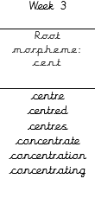

Maths:

History- Find out some more information to help with your History project about the Vikings: The Vikings were a clever and peaceful people. These are some areas you could investigate: Jobs Homes (Long houses) Laws Longships Food God
https://www.youtube.com/watch?v=DR9FGjcG2TMz
Or choose your own and continue your research into other areas of Viking life!

Adult Signature: ………………………………

Say the word → Trace it → Write it in rainbow colours

1. you
you
you
you

2. your
your
your
your

3. they
they
they
they

4. she
she
she
she

5. here
here
here
here

6. love
love
love
love

👍 Extra Practice Fill in the missing letters:
- y _ u
- y _ u r
- t h _ y
- s h _

Write each word 3 times.
Trace over each letter using different colours to make a rainbow.

1. mind
mind
mind
mind

2. behind
behind
behind
behind

3. child
child
child
child

4. children
children
children
children

5. wild
wild
wild
wild

6. climb
climb
climb
climb

🎨 Extra Rainbow Fun
Pick one word and write it in rainbow colours:

Useful links- https://www.bbc.co.uk/bitesize/topics/ztyr9j6
Bottom of Form

🧑‍🌾 Jobs (farmer 🌾, fisherman 🎣, warrior 🗡️)
- Which job was most important for helping Vikings survive?
a) Farmer
b) Actor
c) Shop assistant

- Why were Viking warriors important?
a) They cooked food
b) They protected and attacked
c) They built houses

🏠 Homes (Longhouses)
- Why did Viking families live together in longhouses?
a) To stay warm and safe
b) Because they liked noise
c) Because there were no other buildings

- What were longhouses mainly made from?
a) Glass and steel
b) Wood and thatch
c) Plastic

🍖 Food (meat 🍖, fish 🐟, bread 🍞)
Draw or write:

⚡ Gods (Thor ⚡, Odin 👁️, Loki 🔥)
Draw or write:

Viking research

Jobs
What jobs did Vikings do? Why were they important?

🏠 Homes (Longhouses)
What were longhouses like? How did people live in them?

⚖️ Laws
How did Vikings make decisions? What was a “Thing”?

🚢 Longships
What were longships used for? What made them special?

🍖 Food
What did Vikings eat? How did they get their food?

⚡ Gods
Who were the Viking gods? What did they believe?

