Week Ending:1/5/26 Homework due: Wednesday 6th May

This week…
We have written the opening to our own Fantasy/portal story in English. In Maths we have continued our decimals topic and in RE we have been looking at different churches ( see homework below).

Next week…
Monday – PE day
Sweaty church + Homework ASC (invite only)
Thursday- PE day

At Home… Reading:
Adult’s score
3 entries in your reading record to claim your dojo!

Spellings
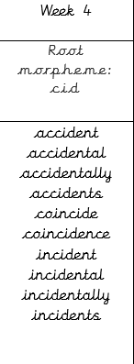
We will be focusing on different spelling patterns each week during ELS spelling sessions (Essential Letters and Sounds) as a follow-on scheme to the phonics the children covered in Key Stage 1. A half term overview has been sent home and is on the website. Using the grids as a reminder-please practice your spellings on the sheets. You must join up

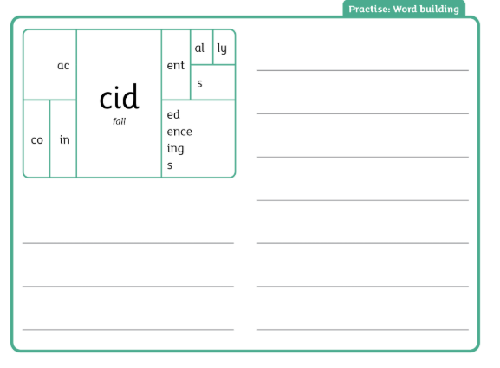

English:

RE- Investigate 2 different local churches in Southport- look on their websites. What do they have on there? Do they have a mission statement which tells us what the church believes? Which demonination do they bleong to (what type of church are they?) Do they have any links to charities they support? Do they do anything to help people in the local area? The links below are suggestions- you can do any local churches. Complete the sheet ready for our RE lesson next week. https://www.stphilipandstpaulwithwesley.org.uk https://christchurchsouthport.org.uk/ https://www.lakesidechurch.uk/
https://www.youtube.com/watch?v=DR9FGjcG2TMz
Adult Signature: ………………………………

🏫 RE Homework Worksheet- Investigating Local Churches (Southport)

⛪ Church 1: ___________________________
1. What is on the church website?
(Write or list things you can find)

2. Mission statement (What does the church believe?)

3. What type of church is it? (Denomination)
(e.g. Catholic, Anglican, Baptist, Pentecostal)

4. Does the church support any charities?
(Write their names if you can find them)

5. How does this church help people in the local area?

⛪ Church 2: ___________________________
1. What is on the church website?

2. Mission statement (What does the church believe?)

3. What type of church is it? (Denomination)

4. Does the church support any charities?

5. How does this church help people in the local area?

Week Ending:1/5/26 Homework due: Wednesday 6th May

This week…
We have written the opening to our own Fantasy/portal story in English. In Maths we have continued our decimals topic and in RE we have been looking at different churches ( see homework below).

Next week…
Monday – PE day
Sweaty church + Homework ASC (invite only)
Thursday- PE day

At Home… Reading:
Adult’s score
3 entries in your reading record to claim your dojo!

Spellings
We will be focusing on different spelling patterns each week during ELS spelling sessions (Essential Letters and Sounds) as a follow-on scheme to the phonics the children covered in Key Stage 1. A half term overview has been sent home and is on the website. Using the grids as a reminder-please practice your spellings on the sheets. You must join up

accident
accidental
accidents
coincide
incident
incidents

English:
RE- Investigate 2 different local churches in Southport- look on their websites. What do they have on there? Do they have a mission statement which tells us what the church believes? Which demonination do they bleong to (what type of church are they?) Do they have any links to charities they support? Do they do anything to help people in the local area? The links below are suggestions- you can do any local churches. Complete the sheet ready for our RE lesson next week. https://www.stphilipandstpaulwithwesley.org.uk https://christchurchsouthport.org.uk/ https://www.lakesidechurch.uk/
https://www.youtube.com/watch?v=DR9FGjcG2TMz
Adult Signature: ………………………………

Week Ending:1/5/26 Homework due: Wednesday 6th May

This week…
We have written the opening to our own Fantasy/portal story in English. In Maths we have continued our decimals topic and in RE we have been looking at different churches ( see homework below).

Next week…
Monday – PE day
Sweaty church + Homework ASC (invite only)
Thursday- PE day

At Home… Reading:
Adult’s score
3 entries in your reading record to claim your dojo!

Spellings
We will be focusing on different spelling patterns each week during ELS spelling sessions (Essential Letters and Sounds) as a follow-on scheme to the phonics the children covered in Key Stage 1. A half term overview has been sent home and is on the website. Using the grids as a reminder-please practice your spellings on the sheets. You must join up

most
only
both
old
cold
gold

English:
RE- Investigate 2 different local churches in Southport- look on their websites. What do they have on there? Do they have a mission statement which tells us what the church believes? Which demonination do they bleong to (what type of church are they?) Do they have any links to charities they support? Do they do anything to help people in the local area? The links below are suggestions- you can do any local churches. Complete the sheet ready for our RE lesson next week. https://www.stphilipandstpaulwithwesley.org.uk https://christchurchsouthport.org.uk/ https://www.lakesidechurch.uk/
https://www.youtube.com/watch?v=DR9FGjcG2TMz
Adult Signature: ………………………………

🏫 RE Homework – Churches in Southport

⛪ Church 1: ____________________
What is on the website?

What type of church is it?

Do they support any charities?

How do they help people?

⛪ Church 2: ____________________
What is on the website?

What type of church is it?

Do they support any charities?

How do they help people?

✏️ Spelling Practice
Words: most • only • both • old • cold • gold

📝 Write each word 3 times
most ________ ________ ________
only ________ ________ ________
both ________ ________ ________
old ________ ________ ________
cold ________ ________ ________
gold ________ ________ ________

🔤 Fill in the missing letters
m _ st
o _ ly
b _ th
o _ d
c _ ld
g _ ld

⭐ Challenge
Circle the correct spelling:
moast / most
onlee / only
boath / both
ould / old
colld / cold
gould / gold

Week Ending:1/5/26 Homework due: Wednesday 6th May

This week…
We have written the opening to our own Fantasy/portal story in English. In Maths we have continued our decimals topic and in RE we have been looking at different churches ( see homework below).

Next week…
Monday – PE day
Sweaty church + Homework ASC (invite only)
Thursday- PE day

At Home… Reading:
Adult’s score
3 entries in your reading record to claim your dojo!

Spellings
We will be focusing on different spelling patterns each week during ELS spelling sessions (Essential Letters and Sounds) as a follow-on scheme to the phonics the children covered in Key Stage 1. A half term overview has been sent home and is on the website. Using the grids as a reminder-please practice your spellings on the sheets. You must join up

come
some
one
once
love
ask

English:
RE- Investigate 2 different local churches in Southport- look on their websites. What do they have on there? Do they have a mission statement which tells us what the church believes? Which demonination do they bleong to (what type of church are they?) Do they have any links to charities they support? Do they do anything to help people in the local area? The links below are suggestions- you can do any local churches. Complete the sheet ready for our RE lesson next week. https://www.stphilipandstpaulwithwesley.org.uk https://christchurchsouthport.org.uk/ https://www.lakesidechurch.uk/
https://www.youtube.com/watch?v=DR9FGjcG2TMz
Adult Signature: ………………………………

Words: come • some • one • once • love • ask

📝 Write each word 3 times
come ________ ________ ________
some ________ ________ ________
one ________ ________ ________
once ________ ________ ________
love ________ ________ ________
ask ________ ________ ________

🔤 Fill in the missing letters
c _ me
s _ me
o _ e
o _ ce
l _ ve
a _ k
Cut out and match each word to the correct meaning.

Words
✂️ come
✂️ some
✂️ one
✂️ once
✂️ love
✂️ ask

Meanings

✂️ to move towards someone
✂️ a small amount
✂️ the number 1
✂️ one time
✂️ a strong happy feeling
✂️ to say a question

