Week Ending:8/5/26 Homework due: Wednesday 13th May

This week…
We have written the opening to our own Fantasy/portal story in English. In Maths we have continued our decimals topic and in RE we have been looking at different churches ( see homework below).

Next week…
Monday – PE day
Sweaty church + Homework ASC (invite only)
Thursday- PE day

At Home… Reading:
Adult’s score
3 entries in your reading record to claim your dojo!

Spellings
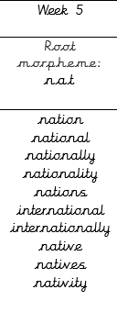
We will be focusing on different spelling patterns each week during ELS spelling sessions (Essential Letters and Sounds) as a follow-on scheme to the phonics the children covered in Key Stage 1. A half term overview has been sent home and is on the website. Using the grids as a reminder-please practice your spellings on the sheets. You must join up
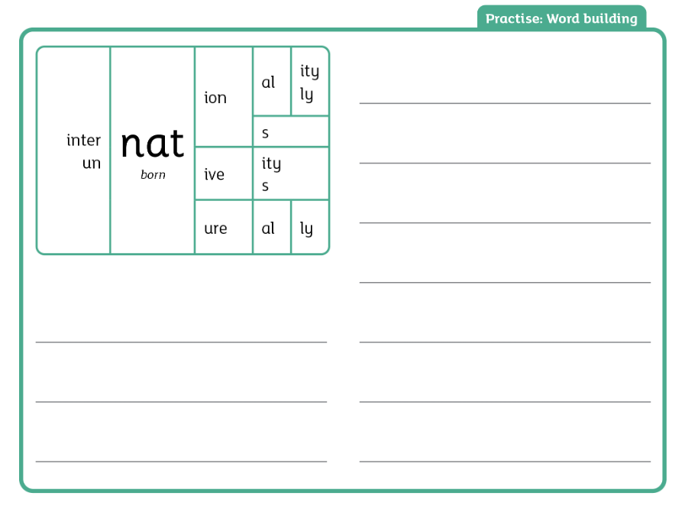

Maths:
See sheet TTRS practice please!

English- SPAG.com Prepositions and Adverbs
https://www.bbc.co.uk/bitesize/articles/zw38srd
Adverbs https://www.bbc.co.uk/bitesize/articles/zgsgxfr
Adult Signature: ………………………………

Week Ending:8/5/26 Homework due: Wednesday 13th May

Next week…
Monday – PE day
Sweaty church + Homework ASC (invite only)
Thursday- PE day

This week…
We have written the opening to our own Fantasy/portal story in English. In Maths we have continued our decimals topic and in RE we have been looking at different churches ( see homework below).

At Home… Reading:
Adult’s score
3 entries in your reading record to claim your dojo!

Spellings
We will be focusing on different spelling patterns each week during ELS spelling sessions (Essential Letters and Sounds) as a follow-on scheme to the phonics the children covered in Key Stage 1. A half term overview has been sent home and is on the website. Using the grids as a reminder-please practice your spellings on the sheets. You must join up

nation
national
nationally
nations
international
native

Maths:
See sheet TTRS practice please!

English- SPAG.com Prepositions and Adverbs
https://www.bbc.co.uk/bitesize/articles/zw38srd
Adverbs https://www.bbc.co.uk/bitesize/articles/zgsgxfr
Adult Signature: ………………………………

Week Ending:8/5/26 Homework due: Wednesday 13th May

Next week…
Monday – PE day
Sweaty church + Homework ASC (invite only)
Thursday- PE day

This week…
We have written the opening to our own Fantasy/portal story in English. In Maths we have continued our decimals topic and in RE we have been looking at different churches ( see homework below).

At Home… Reading:
Adult’s score
3 entries in your reading record to claim your dojo!

Spellings. You must join up
Extra practice sheet included- please complete!

hold
told
every
great
break
steak

Maths:
See sheet TTRS practice please!

English- Prepositions sheet
https://www.bbc.co.uk/bitesize/articles/zw38srd
Adult Signature: ………………………………

Week Ending:8/5/26 Homework due: Wednesday 13th May

Next week…
Monday – PE day
Sweaty church + Homework ASC (invite only)
Thursday- PE day

This week…
We have written the opening to our own Fantasy/portal story in English. In Maths we have continued our decimals topic and in RE we have been looking at different churches ( see homework below).

At Home… Reading:
Adult’s score
3 entries in your reading record to claim your dojo!

Spellings
You must join up
Extra practice sheet included- please complete!

put
push
pull
full
house
our

Maths:
See sheet TTRS practice please!

English- Prepositions sheet
https://www.bbc.co.uk/bitesize/articles/zw38srd
Adult Signature: ………………………………

Year 4 Spelling Practice Sheet
Focus Words:
put • push • pull • full • house our
1. Read & Trace over each word:
put put put ________
push push push ________
pull pull pull ________
full full full ________
house house house ________
our our our __________________

2. Write the Words Write each word 3 times:
put ________ ________ ________
push ________ ________ ________
pull ________ ________ ________
full ________ ________ ________
house ________ ________ ________

3. Fill in the Blanks Choose the correct word:
- I will ______ the door open.
- The bag is ______ of books.
- Please ______ your chair in.
- We live in a big ______.
- Can you ______ the rope?

Year 4 Spelling Practice Sheet
Focus Words:
hold • told • every • great • break • steak

1. Read & Trace Trace over each word:
hold hold hold
told told told ________
every every every
great great great
break break break ________
steak steak steak

2. Write the Words Write each word 3 times:
hold
told ________ ________ ________
every
great
break ________
steak

3. Fill in the Blanks Choose the correct word:
- She ______ me a secret.
- I will ______ your hand.
- We play outside ______ day.
- That was a ______ game!
- Be careful not to ______ the glass.
- He ate a juicy ______ for dinner.



