Week Ending:15/5/26 Homework due: Wednesday 20th May

This week…
In Maths we have continued our decimals topic and in RE we have been looking at Christianity around the world. In Science we made mini wind turbines and will be testing them outside next week.

Next week…
Monday – PE day
Sweaty church + Homework ASC (invite only)
Thursday- PE day

At Home… Reading:
3 entries in your reading record to claim your dojo!
Adult’s score

Spellings
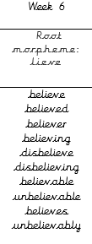
We will be focusing on different spelling patterns each week during ELS spelling sessions (Essential Letters and Sounds) as a follow-on scheme to the phonics the children covered in Key Stage 1. A half term overview has been sent home and is on the website. Using the grids as a reminder-please practice your spellings on the sheets. You must join up
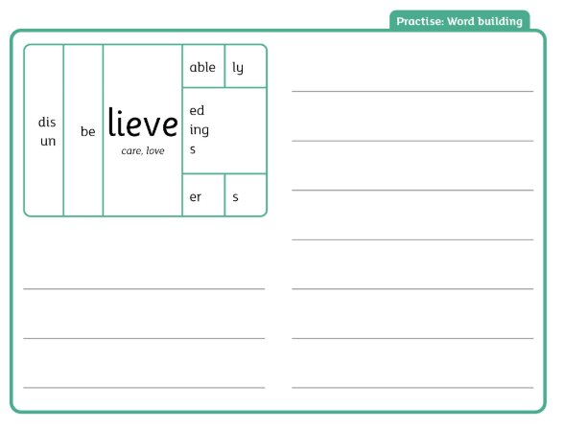

Science- please complete the thought bubbles- choose two questions from our Science lesson and find the answer! Use Google or BBC bitesize to help you!

RE- see sheet .

Adult Signature: ………………………………

RE- Please find out some information about a Christian church service in two different countries.
You could choose countries such as Brazil, Nigeria, Mexico or any other countries of your choice.
Try to find out:
- What happens during the church service
- Is it similar or different to church services in the UK?
- What music might they sing?
- What might people wear to church?
- Are there any special traditions or celebrations?
For example, some churches in Brazil have lively music, singing and community groups for children and families.
Many churches in Nigeria include energetic worship, dancing, Bible teaching and special children’s ministries during services.
If possible, please print a few small pictures of the churches or services to bring into school, as we will be using the information in our RE lesson next week.

RE- Please find out some information about a Christian church service in two different countries.
You could choose countries such as Brazil, Nigeria, Mexico or any other countries of your choice.
Try to find out:
- What happens during the church service
- Is it similar or different to church services in the UK?
- What music might they sing?
- What might people wear to church?
- Are there any special traditions or celebrations?
For example, some churches in Brazil have lively music, singing and community groups for children and families.
Many churches in Nigeria include energetic worship, dancing, Bible teaching and special children’s ministries during services.
If possible, please print a few small pictures of the churches or services to bring into school, as we will be using the information in our RE lesson next week.

Choose two questions you generated in Science on Tuesday in your matrix.
Write both questions in the bubble. Research your two questions at home. Write what you have found in the bubble below.

1)_________________________________

2)_________________________________

Choose two questions you generated in Science on Tuesday in your matrix.
Write both questions in the bubble. Research your two questions at home. Write what you have found in the bubble below.

1)_________________________________

2)_________________________________

Week Ending:15/5/26 Homework due: Wednesday 20th May

Next week…
Monday – PE day
Sweaty church + Homework ASC (invite only)
Thursday- PE day

This week…
In Maths we have continued our decimals topic and in RE we have been looking at Christianity around the world. In Science we made mini wind turbines and will be testing them outside next week.

At Home… Reading:
3 entries in your reading record to claim your dojo!
Adult’s score

Spellings
We will be focusing on different spelling patterns each week during ELS spelling sessions (Essential Letters and Sounds) as a follow-on scheme to the phonics the children covered in Key Stage 1. A half term overview has been sent home and is on the website. Using the grids as a reminder-please practice your spellings on the sheets. You must join up

believe
believed
believer
believing
disbelieve
disbelieving

Science- please complete the thought bubbles- choose two questions from our Science lesson and find the answer! Use Google or BBC bitesize to help you!

RE- see sheet .

Adult Signature: ………………………………

Week Ending:15/5/26 Homework due: Wednesday 20th May

Next week…
Monday – PE day
Sweaty church + Homework ASC (invite only)
Thursday- PE day

This week…
In Maths we have continued our decimals topic and in RE we have been looking at Christianity around the world. In Science we made mini wind turbines and will be testing them outside next week.

At Home… Reading:
3 entries in your reading record to claim your dojo!
Adult’s score

Spellings
We will be focusing on different spelling patterns each week during ELS spelling sessions (Essential Letters and Sounds) as a follow-on scheme to the phonics the children covered in Key Stage 1. A half term overview has been sent home and is on the website. Using the grids as a reminder-please practice your spellings on the sheets. You must join up

pretty
beautiful
after
fast
last
father

Science- please complete the thought bubbles- choose two questions from our Science lesson and find the answer! Use Google or BBC bitesize to help you!

RE- see sheet .

Adult Signature: ………………………………

Next week…
Monday – PE day
Sweaty church + Homework ASC (invite only)
Thursday- PE day

This week…
In Maths we have continued our decimals topic and in RE we have been looking at Christianity around the world. In Science we made mini wind turbines and will be testing them outside next week.

At Home… Reading:
3 entries in your reading record to claim your dojo!
Adult’s score

Spellings
We will be focusing on different spelling patterns each week during ELS spelling sessions (Essential Letters and Sounds) as a follow-on scheme to the phonics the children covered in Key Stage 1. A half term overview has been sent home and is on the website. Using the grids as a reminder-please practice your spellings on the sheets. You must join up

door
floor
poor
because
find
kind

Science- please complete the thought bubbles- choose two questions from our Science lesson and find the answer! Use Google or BBC bitesize to help you!

RE- see sheet .
Adult Signature: ………………………………



