Week Ending:22/5/26 Homework due: Wednesday 3rd June

This week…
We have written explanations in History, RE and English linked to our History topic, The Vikings. We have been working hard on our TTRS scores!
Next week…
Monday – INSET day
Tues- Multiplication check for some children this week
Weds- Railway children theatre show
Thursday- PE day- no PE today
Friday- Active Education day- please wear PE kits

At Home… Reading:
3 entries in your reading record to claim your dojo!
Adult’s score

Spellings
We will be focusing on different spelling patterns each week during ELS spelling sessions (Essential Letters and Sounds) as a follow-on scheme to the phonics the children covered in Key Stage 1. A half term overview has been sent home and is on the website. Using the grids as a reminder-please practice your spellings on the sheets. You must join up!
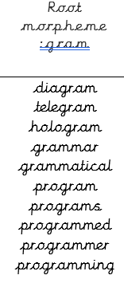
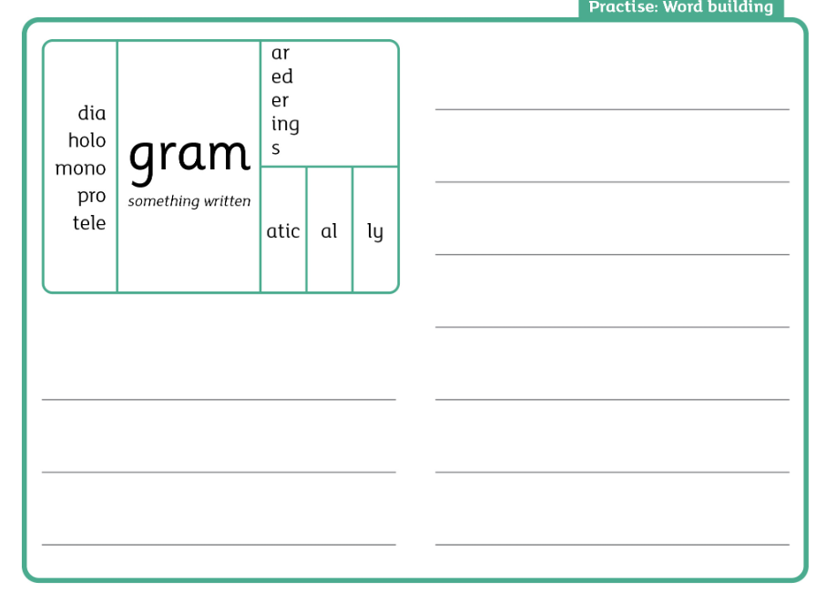

Maths- It is very important that you keep practising your times tables over the half term. I have set you a battle- let’s see who the winner will be when we come back after half term! If you want some extra practice I have put some sheets on our class webpage in the Homework section and included a couple of optional activies with this weeks homework.
Adult Signature: ………………………………

Week Ending:22/5/26 Homework due: Wednesday 3rd June

Next week…
Monday – INSET day
Tues- Multiplication check for some children this week
Weds- Railway children theatre show
Thursday- PE day- no PE today
Friday- Active Education day- please wear PE kits

This week…
We have written explanations in History, RE and English linked to our History topic, The Vikings. We have been working hard on our TTRS scores!

At Home… Reading:
3 entries in your reading record to claim your dojo!
Adult’s score

Spellings
We will be focusing on different spelling patterns each week during ELS spelling sessions (Essential Letters and Sounds) as a follow-on scheme to the phonics the children covered in Key Stage 1. A half term overview has been sent home and is on the website. Using the grids as a reminder-please practice your spellings on the sheets. You must join up

diagram
grammar
program
programs
programmer
programming

Maths- It is very important that you keep practising your times tables over the half term. I have set you a battle- let’s see who the winner will be when we come back after half term! If you want some extra practice I have put some sheets on our class webpage in the Homework section and included a couple of optional activies with this weeks homework.
Adult Signature: ………………………………

Week Ending:22/5/26 Homework due: Wednesday 3rd June

Next week…
Monday – INSET day
Tues- Multiplication check for some children this week
Weds- Railway children theatre show
Thursday- PE day- no PE today
Friday- Active Education day- please wear PE kits

This week…
We have written explanations in History, RE and English linked to our History topic, The Vikings. We have been working hard on our TTRS scores!

At Home… Reading:
3 entries in your reading record to claim your dojo!

Adult’s score
Spellings
We will be focusing on different spelling patterns each week during ELS spelling sessions (Essential Letters and Sounds) as a follow-on scheme to the phonics the children covered in Key Stage 1. A half term overview has been sent home and is on the website. Using the grids as a reminder-please practice your spellings on the sheets. You must join up

class
grass
pass
path
bath
plant

Maths- It is very important that you keep practising your times tables over the half term. I have set you a battle- let’s see who the winner will be when we come back after half term! If you want some extra practice I have put some sheets on our class webpage in the Homework section and included a couple of optional activies with this weeks homework.
Adult Signature: ………………………………

Week Ending:22/5/26 Homework due: Wednesday 3rd June

Next week…
Monday – INSET day
Tues- Multiplication check for some children this week
Weds- Railway children theatre show
Thursday- PE day- no PE today
Friday- Active Education day- please wear PE kits

This week…
We have written explanations in History, RE and English linked to our History topic, The Vikings. We have been working hard on our TTRS scores!

At Home… Reading:
3 entries in your reading record to claim your dojo!
Adult’s score

Spellings
We will be focusing on different spelling patterns each week during ELS spelling sessions (Essential Letters and Sounds) as a follow-on scheme to the phonics the children covered in Key Stage 1. A half term overview has been sent home and is on the website. Using the grids as a reminder-please practice your spellings on the sheets. You must join up

mind
behind
find
child
wild
children

Maths- It is very important that you keep practising your times tables over the half term. I have set you a battle- let’s see who the winner will be when we come back after half term! If you want some extra practice I have put some sheets on our class webpage in the Homework section and included a couple of optional activies with this weeks homework.
Adult Signature: ………………………………

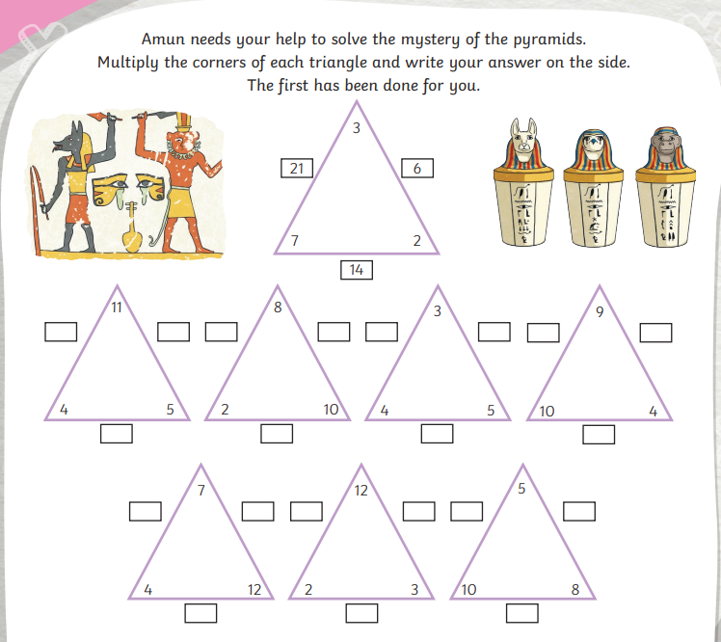

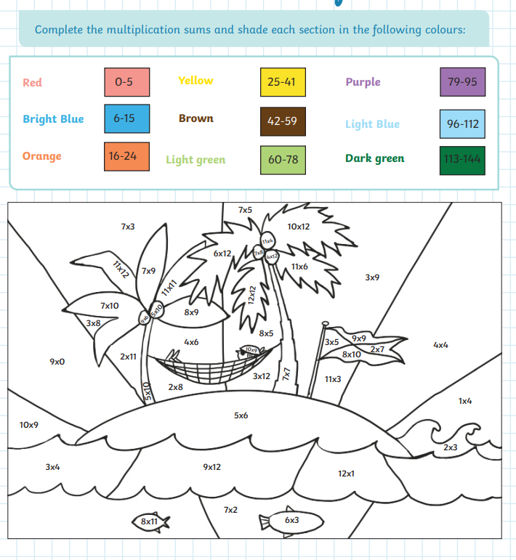

Year 4 Spelling Practice – “ild” Words

Read, Trace and Write
- mind ____________
- behind ____________
- find ____________
- child ____________
- wild ____________
- children ____________

Rainbow Writing
Write each spelling 3 times using different colours.
- mind __________________________
- behind ________________________
- find ___________________________
- child __________________________
- wild ___________________________
- children _______________________

Fill in the Missing Letters
- m _ n d
- b _ h i n d
- f i _ d
- c h i _ d
- w i _ d
- c h i l d r _ n

Year 4 Spelling Practice – “a” Words

Read, Trace and Write
- class _________________________
- grass _________________________
- pass __________________________
- path __________________________
- bath __________________________
- plant _________________________

Fill in the Missing Letters
- c l _ s s
- g r _ s s
- p a _ s
- p a _ h
- b a _ h
- p l a _ t

Rainbow Writing
Write each word 3 times using different colours.
- class __________________________
- grass __________________________
- pass ___________________________
- path ___________________________
- bath ___________________________
- plant __________________________

