Week Ending: 5.6.26 Homework due: Wednesday 10th June 2026

Next week…
- Monday – PE day + Sweaty church ASC
- Wednesday – PE DAY – Parents to come and watch for 1-2pm.
Music- don’t forget your instrument!
DT trip- Christ the King- Tues 23rd June-
Geography trip- Weds 24th June
Please give permission on line to both

This week…
We have had a sporty return to school with a visit from Active Education and preparation for next week’s sports day. Our curriculum newsletter and spellings are now online.
Some children completed their Multiplication check this week- the rest will do next week.

.

At Home… Reading:
Adult’s score
3 entries in your reading record to claim your dojo!

SpellingsUse the table below to practice.


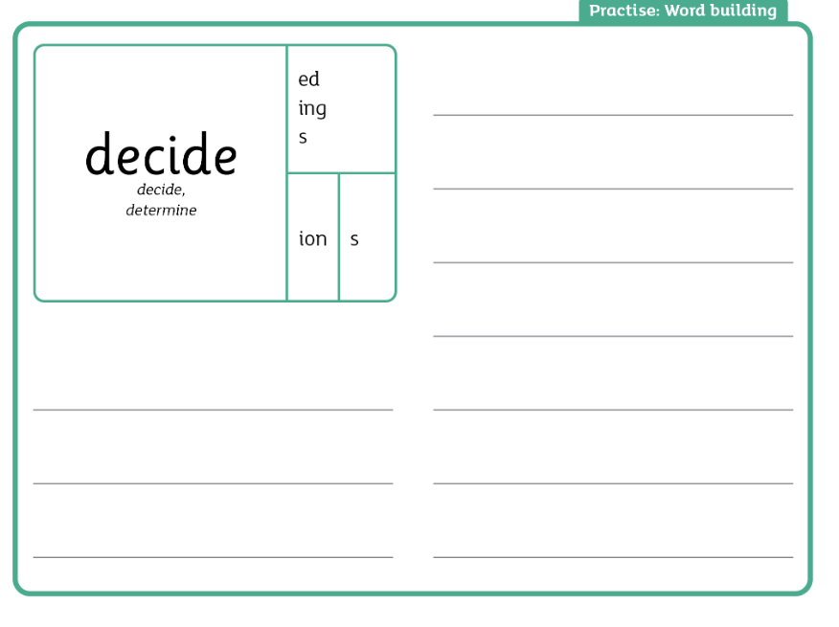

Maths Please complete 10 mins of Garage or Gig practice and then a TTRS soundcheck score . Score

Purple Mash- Complete the multiplication practice games

RE: Please either create or bring in something that speaks to you on the value of Compassion. This is our Summer 2 Christian value.

Please have an adult sign this homework page. Missing homework will be completed Wednesday/Thursday lunchtimes.

Parent/Carer comments:

Adult Signature: ………………………………

Week Ending: 5.6.26 Homework due: Wednesday 10th June 2026

Next week…
- Monday – PE day + Sweaty church ASC
- Wednesday – PE DAY – Parents to come and watch for 1-2pm.
Music- don’t forget your instrument!
DT trip- Christ the King- Tues 23rd June-
Geography trip- Weds 24th June
Please give permission on line to both

This week…
We have had a sporty return to school with a visit from Active Education and preparation for next week’s sports day. Our curriculum newsletter and spellings are now online.
Some children completed their Multiplication check this week- the rest will do next week..

.

At Home… Reading:
Adult’s score
3 entries in your reading record to claim your dojo!

Spellings. Use the table below to practice.

decide
deciding
exercise
circle
medicine
science

Maths Please complete 10 mins of Garage or Gig practice and then a TTRS soundcheck score . Score

Purple Mash- Complete the multiplication practice games

RE: Please either create or bring in something that speaks to you on the value of Compassion. This is our Summer 2 Christian value.

Please have an adult sign this homework page. Missing homework will be completed Wednesday/Thursday lunchtimes.

Parent/Carer comments:

Adult Signature: ………………………………

Week Ending: 5.6.26 Homework due: Wednesday 10th June 2026

Next week…
- Monday – PE day + Sweaty church ASC
- Wednesday – PE DAY – Parents to come and watch for 1-2pm.
Music- don’t forget your instrument!
DT trip- Christ the King- Tues 23rd June-
Geography trip- Weds 24th June
Please give permission on line to both

This week…
We have had a sporty return to school with a visit from Active Education and preparation for next week’s sports day. Our curriculum newsletter and spellings are now online. Some children completed their Multiplication check this week- the rest will do next week.

.

At Home… Reading:
Adult’s score
3 entries in your reading record to claim your dojo!

Spellings. Use the table below to practice.

hour
move
prove
improve
sure
sugar

Maths Please complete 10 mins of Garage or Gig practice and then a TTRS soundcheck score . Score

Purple Mash- Complete the multiplication practice games

RE: Please either create or bring in something that speaks to you on the value of Compassion. This is our Summer 2 Christian value.

Please have an adult sign this homework page. Missing homework will be completed Wednesday/Thursday lunchtimes.

Parent/Carer comments:

Adult Signature: ………………………………

Week Ending: 5.6.26 Homework due: Wednesday 10th June 2026

This week…
We have had a sporty return to school with a visit from Active Education and preparation for next week’s sports day. Our curriculum newsletter and spellings are now online. Some children completed their Multiplication check this week- the rest will do next week.
.

Next week…
- Monday – PE day + Sweaty church ASC
- Wednesday – PE DAY – Parents to come and watch for 1-2pm.
Music- don’t forget your instrument!
DT trip- Christ the King- Tues 23rd June-
Geography trip- Weds 24th June
Please give permission on line to both

.

At Home… Reading:
Adult’s score
3 entries in your reading record to claim your dojo!

Spellings. Use the table below to practice.

climb
old
cold
gold
hold
told

Maths Please complete 10 mins of Garage or Gig practice and then a TTRS soundcheck score . Score

Purple Mash- Complete the multiplication practice games

RE: Please either create or bring in something that speaks to you on the value of Compassion. This is our Summer 2 Christian value.

Please have an adult sign this homework page. Missing homework will be completed Wednesday/Thursday lunchtimes.

Parent/Carer comments:

Adult Signature: ………………………………

Words to Practice
- climb
- old
- cold
- gold
- hold
- told

Read and Write Write each word 2 times in different colours
climb

old

cold

gold

hold

told

Fill in the Missing Letters
- c _ i m b
- o _ d
- c o _ d
- g _ l d
- h o _ d
- t o l _

Spelling Words
- hour
- move
- prove
- improve
- sure
- sugar

Write Each Word twice in different colours
hour

move

prove

improve

sure

sugar

Fill in the Missing Letters
- h _ u r
- m _ v e
- p r _ v e
- i m p r _ v e
- s _ r e
- s u g _ r

