
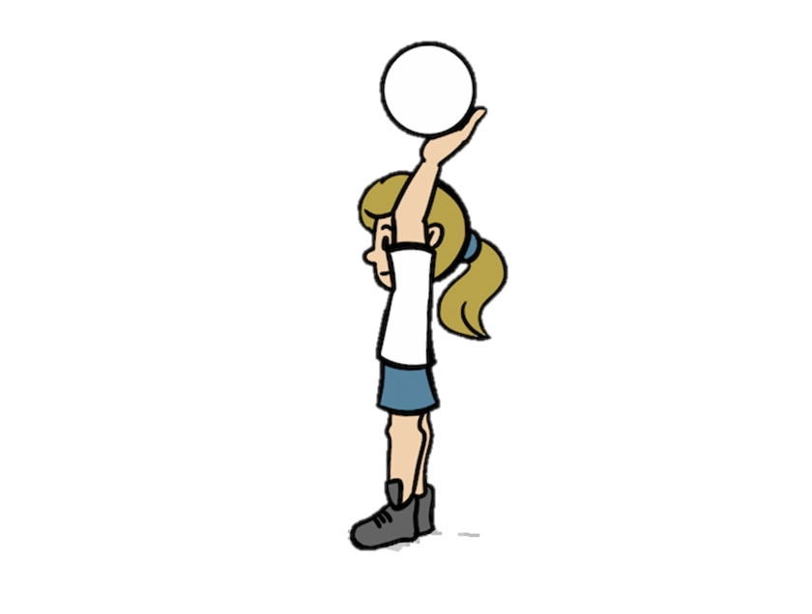

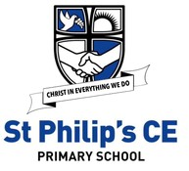
In year 3
Christian value - Perseverance
History
The Iron Age Project!

Welcome back year 3!
PE: Netball!
Mondays and Fridays!

French: Ancient Britain! L’Ancienne de la Grande Bretagne
PSHE: ‘It’s good to be me’ and Grief.
Geography
Latitude and Longitude and The Polar Regions.

English – Shape Poetry,
Persuasive letters and
Biographies.

Maths – Measurement
AND Fractions.

Dates to remember:
Atkinson library visit- Mon 2
Mar
nd
Eco centre visit- Tuesday March 17

th
Class worship- Thursday March
4
19
th Group
Homework- set on a Friday and
due back in by the following Weds.

P
E
-
o
c

a
n
d

G
o
l
f

(
M
o
n

a
n
d

F
r
i

)
D
T
-

M
o
d
e
l

3
D

c
h
a
i
r
P
S
C
H
E
-
G
o
o
d

t
o

b
e

m
e
B
e
i
n
g

r
e
s
p
o
n
s
i
b
l
e

F
r
e
n
c
h
-

C
h
e
z

SPRING 2
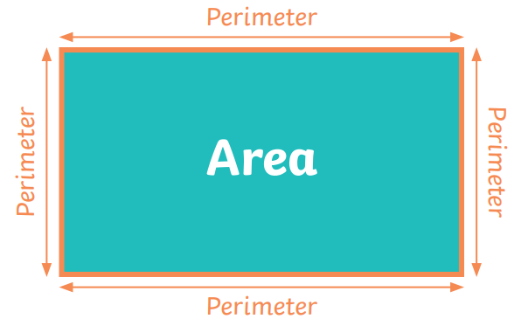
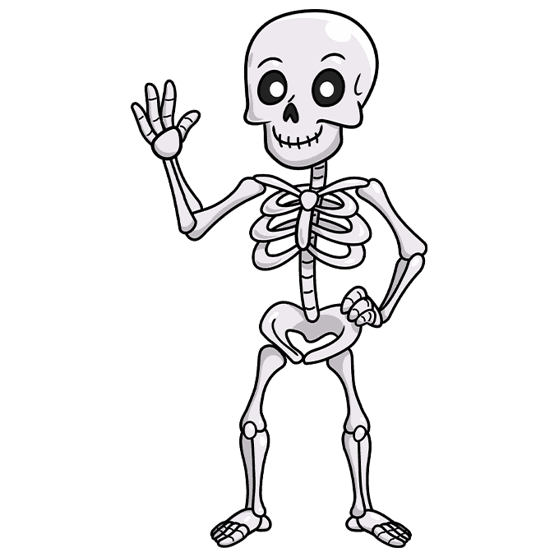

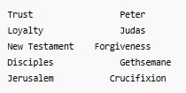

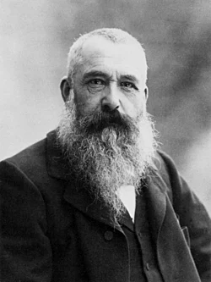
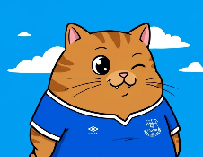

Please visit our class web page for
Art
Monet -
Researching the artist, and creating artwork inspired by Claude Monet.

SPRING 2

H
i
s
t
o
r
y

T
h
e

A
n
g
l
o
S
a
x
o
n
s
Science

R.E - Easter

more information: https://www.stphilipssouthport.com

Music
Recorders:
More musical styles!

In year 3
COMPUTING
Graphing
Branching databases!

Animals
Including
humans

