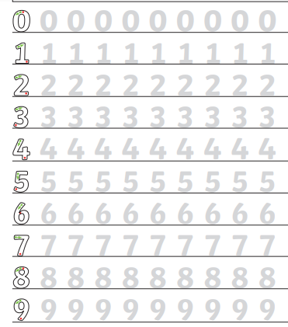
Year 1 homework This week in maths we have been doing lots of counting. Please practise writing numbers correctly – starting at the green arrow. Then fill in the empty boxes – count the dinosaurs.



