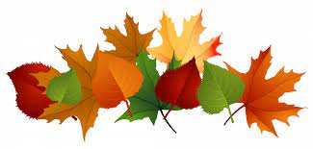
Half Term Homework
During the half term holiday, please read and enjoy the books you have brought home.
After the holidays, we will be learning about autumn in our science lessons, so please look for signs of autumn while you are out and about.
No spellings this week.
Whole school History Homework - Remembrance 2025 Out of school task photo task
RE Homework – Complete the speech bubble for our class reflection book to say how you have made a difference this half term (adult to scribe if needed).

.

