
Please draw a picture and write a sentence about the weekend.
My Weekly Journal

___________________________________________

_____________________________________________________________________________

Homework
Set Thursday 27th November and due in by Wednesday 3rd December
Writing – Draw a picture and write a sentence about your weekend. Please continue on another page if your child would like to write more.
Spelling homework— See spelling book
Topic homework – Make your own Stick Man or Lady (see below.)

Maths Homework – Over the next few weeks, we are going to be working on the rapid recall of addition and subtraction facts to 10. This week please practise addition and subtraction facts for 6. For example –

5+ = 6 6- =5

Christmas presentation – Please help your child to practise their lines for the Christmas performance on Tuesday 9th December (9.15am).

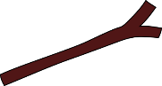
Stick Man Homework
Please find a stick, no longer than 20cm, and decorate it to turn into your own Stick Man or Stick Lady. You can add clothes, hair or accessories of your choice.
The children will be using their characters in school and will be sharing their creations with their friends.
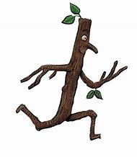
Have fun!


