
Please draw a picture and write a sentence about the weekend.

___________________________________________
My Weekly Journal

_____________________________________________________________________________

Homework
Set Thursday 27th November and due in by Wednesday 3rd December
Writing – Draw a picture and write a sentence about your weekend. Encourage your child to say what they are doing in the picture in full sentences. Ask them who they are with, what they are doing and where they are doing it.
Please finish the picture by asking them to write their name neatly at the top.
Spelling homework— See spelling book
Topic homework – Make your own Stick Man or Lady (see below.)

Maths Homework – Over the next few weeks, we are going to be working on the rapid recall of addition and subtraction facts to 10. This week please practise addition and subtraction facts for 6. For example –

5+ = 6 6- =5

Christmas presentation – Please help your child to practise their lines for the Christmas performance on Tuesday 9th December (9.15am).

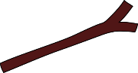
Stick Man Homework
Please find a stick, no longer than 20cm, and decorate it to turn into your own Stick Man or Stick Lady. You can add clothes, hair or accessories of your choice.
The children will be using their characters in school and will be sharing their creations with their friends.
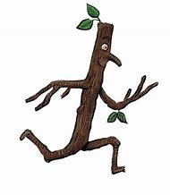
Have fun!


