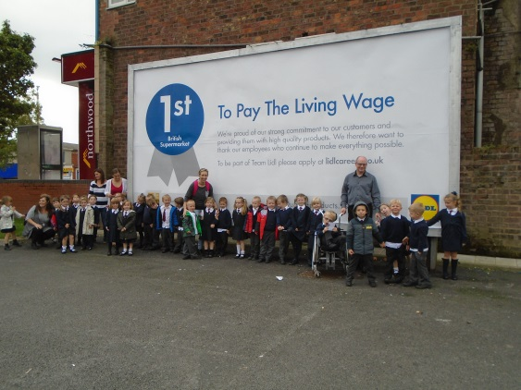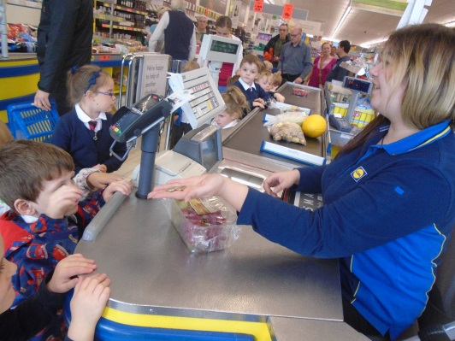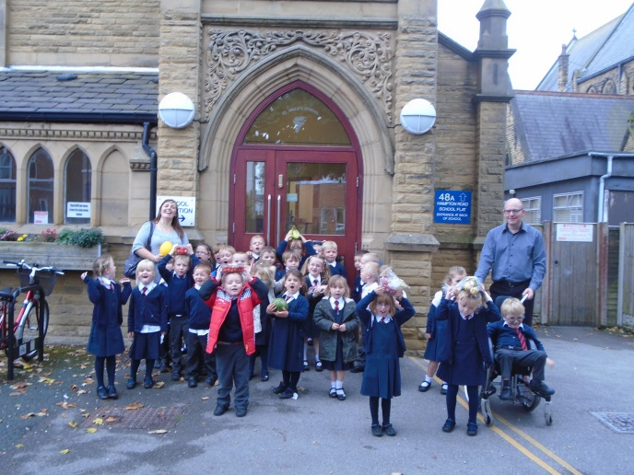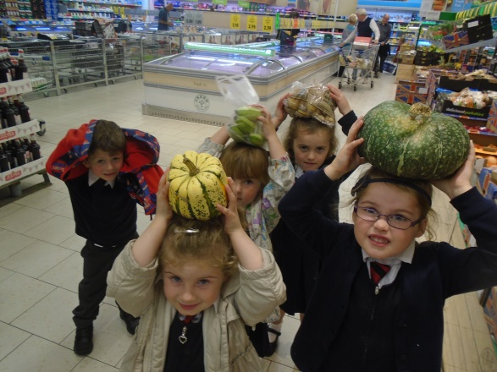
Our Trip to Lidl to buy fruit 6/10/15
Then we cut up the fruit and did some tasting

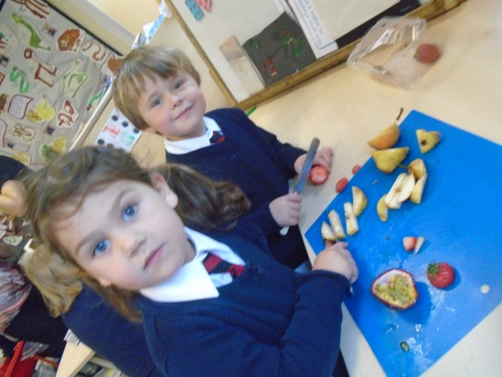
Thank you to all the mums who helped us on our trip. We found lots of different fruit and prepared lots of fruit platters. Some children were more adventurous when tasting the fruits. But everyone tried the fruit and all had a favourite!!


