Friday 19th October
This week  Maths We have continued our work on addition and subtraction.  The children completed addition pyramids and used our bottle tops to solve problems. See photos on the website.  English – The children have been writing poetry this week, based on The Snail and the Whale. It has been a challenging task but the children have persevered. | Next week  Have a fantastic holiday.  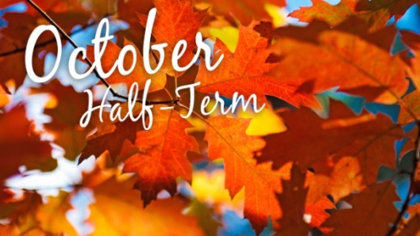  Please could everyone bring a shoe box into school after the holidays – thank you
Homework – addition pyramids
I was really proud of the children’s lovely singing during the harvest festival. Well done everyone.
It was lovely to meet you all at parent’s evening, thank you again for your support.
Friday 19th October
This week  Maths We have continued our work on addition and subtraction.  The children completed addition pyramids and used our bottle tops to solve problems. See photos on the website.  English – The children have been writing poetry this week, based on The Snail and the Whale. It has been a challenging task but the children have persevered. | Next week  Have a fantastic holiday.  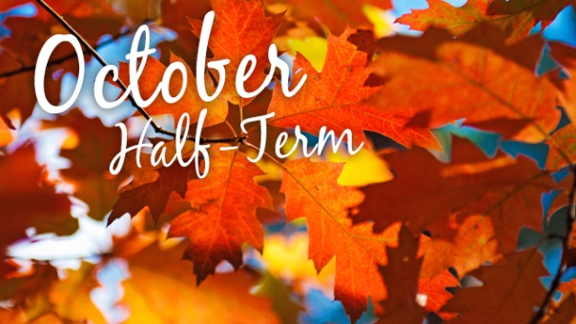  Please could everyone bring a shoe box into school after the holidays – thank you.
Homework – addition pyramids
I was really proud of the children’s lovely singing during the harvest festival. Well done everyone.
It was lovely to meet you all at parent’s evening, thank you again for your support.

