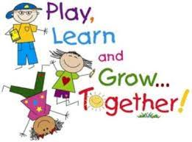
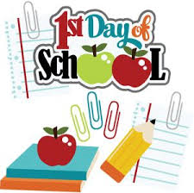


Dear Parents and Carers,
Welcome to the St Philip’s family!
Your children have gotten off to a great start on their new adventure in Reception and we look forward to getting to know them over the next few weeks.
Just a few points to note:
- Children start full time on Thursday 13th September.
- PE will be on a Tuesday and Thursday. Please ensure your child brings a PE kit (fully labelled) in a draw string bag.
- Please bring in a water bottle clearly labelled with your child’s name. Please fill with water only. As we are a healthy school – juice is discouraged.
- Homework books will be sent home after the first full week at school. The homework will be an opportunity for you to be creative with your child. Have fun!
- Your child will have an opportunity to take home a library book from next week. Please use this to share with your child. We cannot overemphasise the importance of reading and sharing books together. Enjoy it!
- Finally, I will be hosting a Parent Workshop when the children have settled into school; taking place on Monday 24th September. This workshop will detail the phonics programme used in Reception as well as showing you some of our maths resources so as you can facilitate your child’s learning at home. It will also be a chance to ask any questions and get to know other parents. I am offering a morning (9am) and an afternoon (2:30pm) session and more details will follow in due course.
If you have any questions, please do not hesitate to arrange an appointment with myself or Mrs Rimmer.
Many thanks,
Mrs. Maguire.
Wow Certificates:
We love celebrating! If your child does something amazing at home or in a club why not fill out a WOW certificate so we can share it in school. Please ask for more or get them from the website.
Thank you
Our topics this half term:
This half term we will be learning all about ourselves. We will be talking about things we like and are good at. We will notice differences between us and celebrate them. We will also be learning about a little girl called Handa; about where she comes from and her lifestyle. As we near the half term we will explore Autumn and Harvest themes. Please see the reverse of this letter for more information about our current topic.

Upcoming dates:
9th September 10.30 – Back to school Sunday in Church
13th September – Children start full time.
24th September – Parent’s Workshop 9am or 2:30pm
3rd October 2.30 – Buddy Assembly (Parents Welcome – School)
5th October – Grandparent’s Day – Information to follow
15th October – Parent’s Evening


Friday 7th September 2018

Dear Parents and Carers,
As part of our “All About Me” topic, we are sending home a paper bag with the children today. Over the weekend, we would like the children to decorate their bag, making it as unique to them as possible using lots of colour, sequins, stickers and pictures. With your help, we would then like the children to put a few small bits into the bag that are important to them or that tell us something about them. Examples include – a favourite book, a photo of their pet or something they made at home – to name but a few things. Please keep these items small and refrain from putting items in which the children cannot be parted from.
Over the course of the next few weeks we will encourage the children to show and tell the class about the contents of their bag. By half term, all bags will be returned.
We would also appreciate it if you could include a family photograph. This will be used for a whole class family collage display and will be returned at the end of the year.
Many thanks for your continued support,
The Reception Team.

